REPUBLIQUE DU CAMEROUN
******************
MINISTÈRE DE L’ENSEIGNEMEN
SUPÉRIEUR
**********
UNIVERSITÉ DE BUEA
********
FACULTÉ D’INGÉNIERIE ET DE
TECHNOLOGIE
******
DEPARTEMENT DU GENIE INFORMATIQUE

REPUBLIC OF CAMEROON
***************
MINISTER OF HIGHER EDUCATION
************
UNIVERSITY OF BUEA
******
FACULTY OF ENGINEERING AND
TECHNOLOGY
*******
DEPARTMENT OF COMPUTER ENGINEERING



CEF440: INTERNET PROGRAMMING AND
MOBILE PROGRAMING
FINAL REPORT

Group 17:
N | NAME | MATRICULE
01 | CHEWACHONG LARY CHE | FE23A031
02 | KWIDJA MBIANDA MARC URIEL | FE23A513
03 | LEKE BRIAN BECHEM | FE23A080
04 | SUME ETONE NZUONKELLE | FE23A145
05 | TAMBONG ELVIRA ETCHI | FE23A158

INSTRUCTORS: Dr. NKEMENI Valery

Certification of Originality
We the undersigned, hereby certify that this dissertation entitled Car Fault Diagnosis Mobile Application titled CAFAD presented by:
CHEWACHONG LARY CHE, Matriculation number FE23A031
KWIDJA MBIANDA MARC URIEL, Matriculation number FE23A513
LEKE BRIAN BECHEM, Matriculation number FE23A080
SUME ETONE NZUONKELLE, Matriculation number FE23A145
TAMBONG ELVIRA ETCHI, Matriculation number FE23A158
has been carried out by Group 17 in the Department of Computer Engineering, Faculty of Engineering and Technology, University of Buea under the supervision of
Dr Nkemeni Valery

This dissertation is authentic and represents the fruits of our own research and efforts.

Date: 29/06/2026

Supervisor Students

Dr Nkemeny Valerie Group 17

DEDICATION
We dedicate this project to God Almighty, the Author and Finisher of our faith. And to our Parents

ACKNOWLEDGEMENTS
The successful completion of this project, Car Fault Diagnosis Mobile Application _ CAFAD would not have been possible without the invaluable support, guidance, and contributions of our lecturer Dr Nkemeny Valery and our team. We would like to express our sincere gratitude to all who have played a role in bringing this innovative automotive diagnostic solution to fruition.

ABSTRACT
Vehicle faults are a major cause of road accidents, increased maintenance costs, and unexpected breakdowns. Many vehicle owners lack the technical knowledge required to identify faults early or determine the appropriate corrective actions. This project presents the design and implementation of CAFAD (Car Fault Diagnosis Mobile Application), an intelligent mobile application developed to assist users in diagnosing vehicle faults quickly and efficiently.
The system was developed following the Software Development Life Cycle (SDLC), incorporating requirements analysis, system design, implementation, testing, and evaluation. The application was built using Flutter for cross-platform mobile development, PostgreSQL as the database management system, and artificial intelligence techniques to support symptom-based diagnosis. In addition to fault diagnosis, the application provides vehicle management, diagnosis history, AI-assisted chat support, and directories of registered mechanics and automobile part sellers, enabling users to access professional services when necessary.
The implemented system offers a user-friendly interface, secure user authentication, efficient data management, and accurate diagnostic support based on user-provided symptoms. Functional testing demonstrated that the application successfully performs its intended operations, including user registration, vehicle management, fault diagnosis, history tracking, and service provider discovery.
The project demonstrates that integrating mobile computing with artificial intelligence can significantly improve the accessibility of vehicle diagnostic services. CAFAD provides a practical and scalable solution that assists vehicle owners in making informed maintenance decisions while reducing the time and cost associated with traditional fault diagnosis.

TABLE OF CONTENT
Contents
Certification of Originality i
DEDICATION ii
ACKNOWLEDGEMENTS iii
ABSTRACT iv
TABLE OF CONTENT v
LISTE OF TABLES ix
LISTE OF FIGURES x
LISTE OF ABREVIATIONS xi
Chapter 1: GENERAL INTRODUCTION 1
1.1. Introduction 1
1.2. Background of study 2
1.3. Problem Statement 3
1.4. Aim and Objective of the Study 4
1.4.1. Aim of the Study 4
1.4.2. Specific Objectives 4
1.5. Scope of the Study 4
1.6. Significance of the Study 5
1.7. Research Methodology 6
Chapter 2: LITERATURE REVIEW 8
2.1. Introduction 8
2.2. General Concepts 8
2.2.1. Vehicle Fault Diagnosis 8
2.2.2. On-Board Diagnosis (OBD-II) 10
2.2.3. Mobile Applications for Vehicle Diagnostics 12
2.2.4. Artificial Intelligence in Vehicle Fault Diagnosis 13
2.2.5. Database Management Systems 15
2.2.6. PostgreSQL Database Management System 16
2.2.7. Flutter Framework 18
2.2.8. Software Development Life Cycle (SDLC) and Agile Methodology 19
2.3. Related Works 21
2.3.1. Existing Systems 21
2.3.2. AI-Powered Diagnostic Systems 22
2.3.3. Computer Vision for Symbol Recognition 22
2.4. Partial Conclusion 22
Chapter 3: ANALYSIS AND DESIGN 24
3.1. Introduction 24
3.2. Proposed Methodology 24
3.2.1. Functional Requirements 25
3.2.2. Non-Functional Requirements 27
3.3. Design 28
3.3.1. System Overview 29
3.3.2. Context Diagram 30
3.3.3. Data Flow Diagram 32
3.3.4. Use Case Diagram 33
3.3.5. Activity Diagram 36
3.3.6. Sequence Diagram 38
3.3.7. Class Diagram 41
3.3.8. Deployment Diagram 43
3.4. Partial Conclusion 44
Chapter 4: IMPLEMENTATION AND RESULTS 46
4.1. Introduction 46
4.2. Tools and Materials Used 46
4.2.1. Hardware Requirements 46
4.2.2. Software Requirements 47
4.2.3. Development Technologies 48
4.3. Description of the Implementation Process 49
4.3.1. Project Initialization 49
4.3.2. Database Implementation 50
4.3.3. User Authentication Module 51
4.3.4. Vehicle Management Module 51
4.3.5. Fault Diagnosis Module 52
4.3.6. AI-Assisted Chat Module 52
4.3.7. Directory of Mechanics and Automobile Parts Sellers 53
4.3.8. Administrator Module 54
4.3.9. System Integration and Testing 54
4.4. Presentation and Interpretation of Results 54
4.4.1. Splash Screen 55
4.4.2. Login Screen 55
4.4.3. User Registration Screen 55
4.4.4. Dashboard 55
4.4.5. Vehicle Management 56
4.4.6. Fault Diagnosis Interface 57
4.4.7. Diagnosis Results 57
4.4.8. AI-Assisted Chat 58
4.4.9. Diagnosis History 58
4.4.10. Mechanics Directory 59
4.4.11. Automobile Parts Sellers Directory 59
4.4.12. User Profile Management 59
4.5. Evaluation of the Solution 60
4.5.1. Functional Evaluation 61
4.5.2. Performance Evaluation 62
4.5.3. Usability Evaluation 62
4.5.4. Security Evaluation 63
4.5.5. Evaluation Against the Project Objectives 63
4.5.6. Limitations of the Solution 63
4.6. Partial Conclusion 64
Chapter 5: CONCLUSION AND FURTHER WORKS 65
5.1. Summary of Findings 65
5.2. Contribution to Engineering and Technology 65
5.3. Recommendations 66
5.4. Difficulties Encountered 67
5.5. Further Works 67
APPENDIX 69
REFERENCES 70

LISTE OF TABLES
Table 1 xi
Table 2 47
Table 3 48
Table 4 62
Table 5 63

LISTE OF FIGURES
Figure 0.1 31
Figure 0.2 32
Figure 0.3 33
Figure 0.4 35
Figure 0.5 37
Figure 0.6 39
Figure 0.7 40
Figure 0.8 41
Figure 0.9 42
Figure 0.10 44
Figure 0.1 50
Figure 0.2 52
Figure 0.3 53
Figure 0.4 56
Figure 0.5 56
Figure 0.6 57
Figure 0.7 57
Figure 0.8 58
Figure 0.9 59
Figure 0.10 60

LISTE OF ABREVIATIONS

Abbreviation | Full Meaning
CAFAD | Car Fault Diagnosis Mobile Application
AI | Artificial Intelligence
API | Application Programming Interface
DBMS | Database Management System
ERD | Entity Relationship Diagram
SDLC | Software Development Life Cycle
UI | User Interface
UX | User Experience
SQL | Structured Query Language
JSON | JavaScript Object Notation
OBD-II | On-Board Diagnostics II
GPS | Global Positioning System
CRUD | Create, Read, Update, Delete
SDK | Software Development Kit
IDE | Integrated Development Environment
BaaS | Backend as a Service
HTTP | HyperText Transfer Protocol
HTTPS | HyperText Transfer Protocol Secure
Table 1

Chapter 1: GENERAL INTRODUCTION

Introduction
The rapid advancement of information and communication technologies has transformed many aspects of everyday life, including the automotive industry. Modern vehicles are equipped with numerous electronic control systems and sensors that continuously monitor their performance and detect potential faults. Although these technologies have improved vehicle reliability and safety, diagnosing faults often requires specialized diagnostic equipment and technical expertise, making the process costly and inaccessible to many vehicle owners.
The widespread adoption of smartphones has created new opportunities for developing mobile applications that provide intelligent and user-friendly solutions to everyday problems. In the automotive sector, mobile applications can assist users in monitoring vehicle conditions, interpreting diagnostic information, and accessing maintenance services more conveniently. By integrating artificial intelligence with mobile computing, these applications can further enhance fault diagnosis by analysing vehicle symptoms and recommending possible causes and corrective actions.
This project focuses on the design and implementation of a Car Fault Diagnosis Mobile Application (CAFAD), an intelligent mobile solution that enables users to diagnose common vehicle faults, manage vehicle information, maintain diagnosis history, and connect with registered mechanics and automobile parts sellers. The application aims to simplify the fault diagnosis process, improve access to maintenance information, and support informed decision-making for vehicle owners.
This chapter introduces the study by presenting its background, identifying the problem addressed, stating the research objectives and questions, defining the scope and significance of the project, outlining the research methodology adopted, and describing the organization of the report.

Background of study
The automotive industry has experienced significant technological advancements over the past few decades. Modern vehicles are no longer purely mechanical systems but are increasingly controlled by electronic components, sensors, and Electronic Control Units (ECUs) that continuously monitor vehicle performance. These systems generate diagnostic information whenever a fault occurs, enabling technicians to identify and resolve problems more efficiently. The introduction of the On-Board Diagnostics (OBD-II) standard further standardized vehicle diagnostics by allowing fault codes to be retrieved using compatible diagnostic devices.
Despite these advancements, vehicle fault diagnosis remains a challenge for many car owners. Conventional diagnostic methods often require specialized equipment and experienced mechanics to interpret diagnostic codes and determine appropriate repair procedures. This dependence on professional services can result in increased maintenance costs, delays in fault detection, and prolonged vehicle downtime, particularly in areas where qualified mechanics or diagnostic centres are not readily accessible.
The widespread use of smartphones and recent developments in mobile application technologies have created opportunities to make vehicle diagnostics more accessible. Mobile applications can provide users with convenient access to vehicle information, maintenance records, and diagnostic assistance directly from their smartphones. Furthermore, the integration of Artificial Intelligence (AI) into mobile applications enables intelligent analysis of user-provided symptoms, allowing the system to suggest possible vehicle faults and recommend appropriate corrective actions.
Several vehicle diagnostic applications are currently available; however, many primarily focus on displaying OBD-II fault codes and require external scanning devices. Others offer limited diagnostic capabilities, provide little guidance for non-technical users, or lack integrated services such as vehicle management, diagnosis history, AI-assisted consultation, and connections to trusted mechanics and automobile parts sellers.
To address these limitations, this project proposes the development of the Car Fault Diagnosis Mobile Application (CAFAD). The application is designed to provide an intelligent and user-friendly platform that assists users in diagnosing common vehicle faults based on observed symptoms, managing vehicle information, maintaining diagnosis records, and locating registered mechanics and automobile parts sellers. By combining mobile computing, artificial intelligence, and a centralized database, the system aims to improve the accessibility, efficiency, and convenience of vehicle fault diagnosis while supporting better vehicle maintenance practices.

Problem Statement
Vehicle maintenance is essential for ensuring road safety, reducing repair costs, and extending the lifespan of automobiles. However, many vehicle owners are unable to identify the causes of faults when warning signs or abnormal vehicle behaviors occur. Diagnosing these faults often requires visiting a mechanic, a process that can be time-consuming, expensive, and inconvenient, especially in areas where qualified technicians or diagnostic equipment are not readily available.
Although modern vehicles are equipped with On-Board Diagnostics (OBD-II) systems that generate fault codes, interpreting these codes generally requires specialized scanning devices and technical expertise. Consequently, many vehicle owners remain dependent on professional mechanics even for minor issues, leading to unnecessary repair costs and delays in addressing faults before they become more serious.
Existing mobile applications provide partial solutions by displaying diagnostic information or requiring external OBD-II scanners. However, many of these applications are not designed for non-technical users and often lack intelligent symptom-based diagnosis, comprehensive vehicle management, diagnosis history, and integrated access to trusted mechanics and automobile parts sellers. This limits their effectiveness as complete vehicle maintenance solutions.
Therefore, there is a need for an intelligent, user-friendly, and integrated mobile application that enables users to diagnose common vehicle faults based on observable symptoms, maintain vehicle records, store diagnosis history, and easily connect with qualified mechanics and automobile parts sellers. Addressing these challenges motivated the development of the Car Fault Diagnosis Mobile Application (CAFAD).

Aim and Objective of the Study

Aim of the Study
The main aim of this project is to design and implement an intelligent Car Fault Diagnosis Mobile Application (CAFAD) that assists vehicle owners in diagnosing common vehicle faults, managing vehicle information, and accessing automobile maintenance services through a user-friendly mobile platform.

Specific Objectives
The specific objectives of this study are to:
- Design and develop a cross-platform mobile application for car fault diagnosis.
- Develop an intelligent symptom-based diagnosis module that identifies possible vehicle faults and recommends appropriate solutions.
- Implement a secure user authentication system for different categories of users.
- Provide a vehicle management module that enables users to register and manage their vehicles.
- Maintain a diagnosis history to allow users to review previous diagnostic results.
- Integrate an AI-assisted chat feature to provide users with additional guidance on vehicle-related issues.
- Develop a platform that connects vehicle owners with registered mechanics and automobile parts sellers.
- Evaluate the developed application through functional, usability, performance and security testing.

Scope of the Study
This study focuses on the design and implementation of the Car Fault Diagnosis Mobile Application (CAFAD), an intelligent mobile application developed to assist vehicle owners in identifying common vehicle faults based on observable symptoms. The application is intended to provide users with a convenient and accessible platform for basic vehicle diagnosis and maintenance support.
The scope of the project includes user registration and authentication, vehicle registration and management, symptom-based fault diagnosis, AI-assisted chat support, diagnosis history management, and directories of registered mechanics and automobile parts sellers. The application also enables mechanics and parts sellers to create accounts and manage their profiles, allowing vehicle owners to identify and contact service providers when maintenance or replacement parts are required.
The system is designed as a cross-platform mobile application developed using Flutter with a PostgreSQL database for secure data storage and management. It emphasizes ease of use, efficient information management, and intelligent diagnostic assistance through a modern mobile interface.
However, the study has certain limitations. The application diagnoses only common vehicle faults based on symptoms provided by users and does not perform real-time vehicle diagnostics through direct communication with a vehicle's On-Board Diagnostics (OBD-II) system. The accuracy of the diagnosis depends on the correctness and completeness of the symptoms entered by the user. In addition, the application is not intended to replace professional vehicle inspection or repair services but rather to assist users in making informed maintenance decisions and facilitate access to qualified mechanics and automobile parts sellers.

Significance of the Study
The Car Fault Diagnosis Mobile Application (CAFAD) provides a practical solution to challenges associated with vehicle fault diagnosis and maintenance. By integrating mobile computing and artificial intelligence, the application offers several benefits to different stakeholders.
Car Owners: The application enables vehicle owners to identify common vehicle faults based on observable symptoms without requiring immediate access to specialized diagnostic equipment. It also allows users to manage vehicle information, maintain diagnosis history, and make informed decisions regarding vehicle maintenance, thereby reducing unnecessary repair costs and saving time.
Mechanics: Registered mechanics benefit from increased visibility by creating professional profiles within the application. This enables them to connect with potential customers who require vehicle inspection, diagnosis, or repair services, thereby expanding their customer base.
Automobile Parts Sellers: The platform provides automobile parts sellers with an opportunity to promote their businesses by making their services accessible to users seeking replacement parts after receiving diagnostic recommendations. This improves communication between sellers and potential customers.

Research Methodology
This study adopted the Software Development Life Cycle (SDLC) as the guiding methodology for the design and implementation of the Car Fault Diagnosis Mobile Application (CAFAD). An Agile development approach was employed to enable incremental development, continuous testing, and regular improvements throughout the project.
The research began with a comprehensive requirement gathering phase, during which information was collected on the challenges faced by vehicle owners in diagnosing and managing vehicle faults. Functional and non-functional requirements were identified through literature review, analysis of existing vehicle diagnostic applications, and system requirement analysis.
The system was then analyzed and designed using Unified Modeling Language (UML) diagrams, including use case diagrams, activity diagrams, sequence diagrams, class diagrams, and an Entity Relationship Diagram (ERD) to model the database structure. These design models provided a clear blueprint for the implementation phase.
The implementation phase involved the development of the mobile application using Flutter, while PostgreSQL served as the database management system for storing user, vehicle, diagnosis, and service provider information. Artificial intelligence techniques were incorporated to support symptom-based vehicle fault diagnosis and AI-assisted user interaction.
Finally, the developed application was subjected to functional testing to verify that all modules operated according to the specified requirements. The testing process evaluated key functionalities such as user authentication, vehicle management, fault diagnosis, diagnosis history, AI-assisted chat, and the management of mechanics and automobile parts sellers. The results of these tests were used to assess the performance and usability of the application.

Chapter 2: LITERATURE REVIEW

2.1. Introduction
A literature review provides a comprehensive examination of existing knowledge, theories, technologies, and previous studies relevant to a research topic. It enables researchers to understand the current state of knowledge, identify limitations in existing solutions, and establish the need for the proposed study. In software engineering projects, a literature review also provides the theoretical and technological foundation upon which the proposed system is designed and implemented.
This chapter reviews the concepts and technologies related to vehicle fault diagnosis, On-Board Diagnostics (OBD-II), mobile diagnostic applications, artificial intelligence, database management systems, and software development methodologies. It also examines previous studies and existing vehicle diagnostic applications to identify their strengths and limitations. The chapter concludes by identifying the research gap addressed by the Car Fault Diagnosis Mobile Application (CAFAD) and highlighting the contribution of the proposed system.

2.2. General Concepts

2.2.1. Vehicle Fault Diagnosis
Vehicle fault diagnosis is the process of identifying, analyzing, and determining the causes of faults or malfunctions that affect the normal operation of a motor vehicle. It involves detecting abnormal conditions within various vehicle systems, such as the engine, transmission, braking system, electrical system, and emission control system, to facilitate timely maintenance and repair. Effective fault diagnosis helps improve vehicle performance, enhance road safety, reduce maintenance costs, and prevent minor issues from developing into major mechanical failures.
Traditionally, vehicle fault diagnosis relied on manual inspection and the experience of skilled mechanics. Technicians examined visible symptoms such as unusual noises, excessive exhaust smoke, engine vibrations, warning lights, fluid leaks, and changes in vehicle performance to identify possible faults. Although this approach remains valuable, it is often time-consuming and depends heavily on the expertise of the technician, making the diagnosis process susceptible to human error and inconsistent results.
The rapid advancement of automotive technology has transformed vehicle fault diagnosis through the integration of electronic control systems. Modern vehicles are equipped with numerous sensors and Electronic Control Units (ECUs) that continuously monitor the condition and performance of different vehicle components. Whenever an abnormal condition is detected, the ECU records a Diagnostic Trouble Code (DTC), which provides valuable information about the nature and location of the fault. This information can be retrieved using diagnostic tools, enabling faster and more accurate fault identification.
Vehicle fault diagnosis can generally be classified into three main approaches. The first is manual diagnosis, which relies on physical inspection and the experience of mechanics. The second is computer-assisted diagnosis, which uses electronic diagnostic equipment, such as OBD-II scanners, to retrieve and interpret diagnostic trouble codes generated by the vehicle. The third is intelligent fault diagnosis, which applies artificial intelligence techniques, including expert systems, machine learning, and natural language processing, to analyse symptoms, identify probable faults, and recommend appropriate corrective actions. Intelligent diagnostic systems improve accessibility by assisting users who may not possess advanced automotive knowledge.
Recent advances in artificial intelligence and mobile computing have further enhanced vehicle fault diagnosis. Intelligent mobile applications can analyse user-reported symptoms, provide preliminary diagnostic results, recommend possible solutions, and connect users with professional maintenance services. These applications improve convenience by allowing vehicle owners to obtain diagnostic assistance without immediately visiting a repair workshop. They also support preventive maintenance by helping users identify potential problems before they become critical.
Despite these technological developments, many existing vehicle diagnostic solutions still require specialized OBD-II scanners or technical expertise to interpret diagnostic information. Consequently, there remains a need for intelligent, user-friendly, and integrated mobile applications that provide symptom-based diagnosis while offering additional services such as vehicle management, diagnosis history, and access to trusted mechanics and automobile parts sellers. The Car Fault Diagnosis Mobile Application (CAFAD) developed in this study addresses these needs by combining intelligent diagnosis with mobile technology to provide a more accessible and comprehensive vehicle maintenance solution.

2.2.2. On-Board Diagnosis (OBD-II)
On-Board Diagnostics II (OBD-II) is a standardized vehicle self-diagnostic and reporting system designed to monitor the performance of a vehicle's engine and other critical components. It enables the continuous monitoring of vehicle systems and assists in detecting malfunctions that may affect engine performance, emissions, fuel efficiency, and overall vehicle operation. Since its introduction in the mid-1990s, OBD-II has become a mandatory standard for most passenger vehicles manufactured worldwide, providing a uniform method for vehicle diagnostics and maintenance.
The OBD-II system consists of several interconnected components, including Electronic Control Units (ECUs), sensors, actuators, and a standardized 16-pin diagnostic connector. Sensors continuously monitor various operating parameters such as engine temperature, oxygen levels, fuel pressure, air intake, and engine speed. The collected information is processed by the ECU, which evaluates whether the vehicle is operating within acceptable limits.
Whenever the ECU detects an abnormal operating condition, it stores a Diagnostic Trouble Code (DTC) in its memory and may illuminate the Malfunction Indicator Lamp (MIL), commonly known as the "Check Engine" light, to alert the driver. Each DTC follows an international standardized format that identifies the vehicle system in which the fault has occurred. These codes can be retrieved using compatible OBD-II scanners, enabling technicians to diagnose faults more quickly and accurately.
Diagnostic Trouble Codes are generally classified into four categories based on the vehicle system involved:
- Powertrain (P-codes): Related to the engine, transmission, and fuel systems.
- Body (B-codes): Associated with body components such as airbags, lighting systems, and climate control.
- Chassis (C-codes): Concern braking, steering, suspension, and other chassis-related systems.
- Network (U-codes): Indicate communication failures between different Electronic Control Units within the vehicle.
One of the major advantages of OBD-II is its ability to support early fault detection, thereby reducing maintenance costs and improving vehicle reliability. By identifying faults before they develop into serious mechanical problems, OBD-II contributes to improved road safety, reduced vehicle downtime, and lower exhaust emissions. The standardized diagnostic interface also allows diagnostic tools from different manufacturers to communicate with a wide range of vehicles, simplifying maintenance procedures for technicians.
Despite its numerous benefits, OBD-II has certain limitations. The system primarily detects faults that are electronically monitored by the vehicle's sensors and control units. Mechanical faults that do not generate electronic error codes may remain undetected. In addition, interpreting Diagnostic Trouble Codes often requires specialized scanning devices and technical expertise, making it difficult for ordinary vehicle owners to understand the diagnostic information without professional assistance.
Recent developments have combined OBD-II technology with mobile applications, Bluetooth communication, cloud computing, and artificial intelligence to provide more accessible vehicle diagnostic services. Bluetooth-enabled OBD-II adapters allow smartphones to retrieve vehicle diagnostic data in real time, while AI-based systems assist in interpreting fault codes and recommending possible corrective actions.
Although the Car Fault Diagnosis Mobile Application (CAFAD) developed in this study does not currently communicate directly with an OBD-II scanner, the principles of OBD-II provide an important foundation for understanding modern vehicle diagnostics. Instead of relying on fault codes generated by vehicle sensors, CAFAD employs an intelligent symptom-based diagnosis approach that enables users to identify common vehicle faults through observable symptoms. This approach makes diagnostic assistance more accessible, particularly for users who do not possess OBD-II diagnostic equipment.

2.2.3. Mobile Applications for Vehicle Diagnostics
The rapid growth of mobile computing has significantly transformed the way people access information and services. Smartphones have evolved from simple communication devices into powerful computing platforms capable of supporting complex applications across various sectors, including healthcare, education, finance, transportation, and automotive services. In the automotive industry, mobile applications have become valuable tools for assisting vehicle owners in monitoring vehicle health, scheduling maintenance, accessing repair information, and diagnosing common vehicle faults.
Mobile applications for vehicle diagnostics are software solutions that enable users to obtain information about the condition of their vehicles through their smartphones or tablets. These applications may operate by communicating with an OBD-II scanner through Bluetooth or Wi-Fi, or by allowing users to manually provide vehicle symptoms for intelligent diagnosis. Depending on their capabilities, such applications can display Diagnostic Trouble Codes (DTCs), explain fault meanings, monitor vehicle performance in real time, track maintenance history, and provide recommendations for corrective actions.
One of the major advantages of mobile diagnostic applications is their convenience. Vehicle owners can access diagnostic information anytime and anywhere without necessarily visiting a repair workshop. This facilitates early fault detection, encourages preventive maintenance, and reduces unnecessary repair expenses. In addition, mobile applications provide intuitive graphical user interfaces that simplify the presentation of technical information, making vehicle diagnostics more accessible to users with limited automotive knowledge.
Modern mobile diagnostic applications often incorporate advanced technologies such as cloud computing, artificial intelligence, and Internet of Things (IoT) connectivity to enhance their functionality. Cloud-based platforms allow users to securely store vehicle records and diagnostic history, while artificial intelligence enables applications to analyse user-reported symptoms and recommend probable faults and maintenance solutions. Some applications also provide GPS-based services that help users locate nearby mechanics, service centres, and automobile parts suppliers, thereby improving the overall maintenance experience.
Despite these advancements, existing mobile diagnostic applications have several limitations. Many applications depend on external OBD-II scanners, which increase the cost of use and may not be readily available to all vehicle owners. Others focus primarily on displaying fault codes without providing sufficient explanations or practical guidance for non-technical users. Some applications also lack integrated features such as vehicle management, diagnosis history, AI-assisted consultation, and directories of trusted mechanics and automobile parts sellers. These limitations reduce their effectiveness as comprehensive vehicle maintenance solutions.
The Car Fault Diagnosis Mobile Application (CAFAD) was developed to address these shortcomings by providing an integrated mobile platform that combines intelligent symptom-based diagnosis with vehicle management, diagnosis history, AI-assisted chat support, and directories of registered mechanics and automobile parts sellers. Unlike applications that rely exclusively on OBD-II devices, CAFAD enables users to obtain preliminary diagnostic assistance based on observable symptoms, making vehicle fault diagnosis more accessible, affordable, and user-friendly.

2.2.4. Artificial Intelligence in Vehicle Fault Diagnosis
Artificial Intelligence (AI) is a branch of computer science that focuses on the development of computer systems capable of performing tasks that normally require human intelligence. These tasks include learning from data, reasoning, problem-solving, decision-making, understanding natural language, and recognizing patterns. Over the past decade, AI has become a key technology in many industries, including healthcare, finance, manufacturing, transportation, and the automotive sector, where it has significantly improved the efficiency and accuracy of intelligent systems.
In vehicle fault diagnosis, AI is used to analyse symptoms, sensor readings, historical maintenance records, and diagnostic data to identify potential faults and recommend appropriate corrective actions. Unlike conventional diagnostic systems that rely solely on predefined rules or fault codes, AI systems can process large volumes of information, identify hidden relationships among symptoms, and provide more intelligent diagnostic support. This capability enhances the speed, consistency, and accuracy of fault detection while reducing dependence on human expertise.
Several AI techniques have been applied in vehicle fault diagnosis. Expert systems use a knowledge base and inference rules derived from experienced mechanics to determine the most probable cause of a vehicle fault. These systems emulate human reasoning by comparing user-provided symptoms with stored diagnostic rules and suggesting appropriate maintenance recommendations. Because of their explainable decision-making process, expert systems remain widely used in intelligent diagnostic applications.
Machine Learning (ML) has also become an important approach to vehicle diagnostics. Machine learning algorithms learn from historical diagnostic data and continuously improve their ability to recognize fault patterns. Supervised learning algorithms are commonly used to classify vehicle faults based on labelled training data, while unsupervised learning techniques identify hidden patterns and anomalies in vehicle operating data. Deep learning models have further improved diagnostic accuracy by processing complex sensor information collected from modern vehicles.
Another important AI technology is Natural Language Processing (NLP), which enables computers to understand and process human language. NLP allows users to interact with diagnostic systems using conversational language instead of technical commands. AI-powered chat assistants can interpret user questions, explain diagnostic results, provide maintenance advice, and answer common vehicle-related queries in a simple and user-friendly manner. This improves the accessibility of diagnostic systems, particularly for users with limited technical knowledge.
The application of AI in vehicle fault diagnosis offers several advantages. It improves diagnostic accuracy by analysing multiple symptoms simultaneously, reduces the time required to identify faults, supports predictive maintenance by detecting potential failures early, and enhances the overall user experience through intelligent recommendations and interactive assistance. AI-based systems also contribute to reducing maintenance costs by helping vehicle owners address minor issues before they develop into major mechanical failures.
Despite these advantages, AI-based diagnostic systems also face several challenges. Their performance depends on the quality and completeness of the available data and knowledge base. Incorrect or incomplete symptom descriptions may reduce diagnostic accuracy, while complex vehicle faults may still require physical inspection and professional expertise. Furthermore, AI systems require continuous updating to accommodate new vehicle models, emerging technologies, and evolving diagnostic knowledge.
The Car Fault Diagnosis Mobile Application (CAFAD) incorporates artificial intelligence to provide intelligent symptom-based fault diagnosis and AI-assisted user interaction. Instead of requiring users to interpret technical diagnostic codes, the application analyses symptoms entered by the user and suggests possible vehicle faults together with recommended corrective actions. The integrated AI chat feature further assists users by answering vehicle-related questions and providing maintenance guidance in a conversational manner. This combination of artificial intelligence and mobile technology enhances the accessibility, usability, and effectiveness of vehicle fault diagnosis for both experienced and non-technical users.

2.2.5. Database Management Systems
A Database Management System (DBMS) is a software system that enables users and applications to create, store, retrieve, update, and manage data in an organized and secure manner. It acts as an interface between the database and the users or application programs, ensuring that data is stored efficiently while maintaining its integrity, consistency, and security. Database management systems have become essential components of modern software applications because they provide reliable mechanisms for handling large volumes of information.
Databases play a vital role in mobile applications by providing persistent storage for user information, application settings, transaction records, and other operational data. Unlike temporary memory, which loses its contents when an application is closed, databases allow information to be permanently stored and retrieved whenever needed. This capability enables mobile applications to maintain user accounts, preserve application history, synchronize information, and support personalized user experiences.
Database Management Systems perform several important functions. They facilitate data definition by allowing developers to create database structures such as tables, relationships, and constraints. They also support efficient data manipulation through operations such as inserting, updating, deleting, and retrieving records. Furthermore, DBMSs enforce data integrity by preventing inconsistent or duplicate information, implement access control to protect sensitive data, and provide backup and recovery mechanisms to minimize data loss in the event of system failures.
Database Management Systems can generally be categorized into relational and non-relational databases. Relational Database Management Systems (RDBMSs) organize data into tables consisting of rows and columns, with relationships established through primary and foreign keys. They use the Structured Query Language (SQL) to manage and retrieve data and are widely recognized for their consistency, reliability, and support for complex queries. Examples include PostgreSQL, MySQL, Oracle Database, and Microsoft SQL Server. In contrast, Non-Relational (NoSQL) databases store data using flexible structures such as documents, key-value pairs, graphs, or column families. These databases are commonly used in applications requiring high scalability and flexible data models, with examples including MongoDB, Cassandra, and Redis.
A well-designed database contributes significantly to the performance and reliability of a mobile application. It ensures that data can be accessed efficiently, reduces redundancy through proper normalization, maintains consistency across multiple users, and supports concurrent access without compromising data accuracy. Security features such as authentication, authorization, encryption, and transaction management further protect sensitive information from unauthorized access or accidental modification.
In the context of vehicle fault diagnosis applications, a database is essential for storing user profiles, vehicle details, diagnostic records, maintenance history, mechanics' information, automobile parts sellers' information, and AI-generated diagnostic results. Efficient database management enables users to retrieve previous diagnoses, update vehicle information, and access maintenance services whenever required.
The Car Fault Diagnosis Mobile Application (CAFAD) relies on a relational database to manage all system information securely and efficiently. The database serves as the central repository for user accounts, vehicle records, fault diagnoses, diagnosis history, mechanics, automobile parts sellers, and other application data. This ensures data consistency, supports secure access to information, and enables the smooth operation of the application's various functional modules.

2.2.6. PostgreSQL Database Management System
PostgreSQL is a powerful, open-source Relational Database Management System (RDBMS) that is widely recognized for its reliability, scalability, security, and compliance with SQL standards. Originally developed at the University of California, Berkeley, PostgreSQL has evolved into one of the world's most advanced database systems, supporting both small-scale and enterprise-level applications. Its robust architecture and extensive feature set make it a preferred choice for web, desktop, and mobile application development.
One of the key strengths of PostgreSQL is its support for the Structured Query Language (SQL), which enables developers to create, retrieve, update, and manage data efficiently. The database also supports advanced features such as transactions, foreign key constraints, views, indexes, triggers, stored procedures, and concurrency control. These capabilities ensure that data remains accurate, consistent, and secure even when multiple users access the system simultaneously.
PostgreSQL employs the Multi-Version Concurrency Control (MVCC) mechanism, which allows multiple users to perform database operations concurrently without causing conflicts or compromising data integrity. This feature significantly improves system performance by enabling simultaneous read and write operations while maintaining data consistency. In addition, PostgreSQL provides automatic crash recovery, backup mechanisms, and transaction logging, which enhance the reliability and availability of stored data.
Security is another important feature of PostgreSQL. The database supports user authentication, role-based access control, Secure Sockets Layer (SSL) encryption, and detailed permission management to protect sensitive information from unauthorized access. These security mechanisms are particularly important for applications that store personal information and operational records, ensuring compliance with data protection best practices.
Compared with other relational database systems such as MySQL and Microsoft SQL Server, PostgreSQL offers greater extensibility and stronger support for advanced SQL features. Its open-source nature eliminates licensing costs while benefiting from continuous improvements contributed by a large global community of developers. These characteristics make PostgreSQL a cost-effective and reliable solution for academic, commercial, and industrial software projects.
In the Car Fault Diagnosis Mobile Application (CAFAD), PostgreSQL serves as the central repository for all application data. It stores user account information, vehicle records, symptom data, diagnostic results, diagnosis history, mechanics' profiles, automobile parts sellers' profiles, and other operational data required by the system. The relational structure of PostgreSQL ensures that relationships among these entities are maintained through primary and foreign keys, thereby minimizing data redundancy and preserving data integrity.
The selection of PostgreSQL for this project was influenced by its high performance, scalability, security, and compatibility with modern backend technologies. Its ability to efficiently manage large volumes of structured data while supporting concurrent access makes it well suited for a mobile application such as CAFAD, where multiple categories of users—including vehicle owners, mechanics, and automobile parts sellers—interact with the system simultaneously. Consequently, PostgreSQL provides a stable and reliable foundation for the application's data management requirements.

2.2.7. Flutter Framework
Flutter is an open-source Software Development Kit (SDK) developed by Google for building cross-platform applications from a single codebase. First released in 2017, Flutter enables developers to create high-performance applications for Android, iOS, web, desktop, and embedded platforms using the Dart programming language. Its ability to deliver near-native performance while reducing development time has made it one of the most popular frameworks for modern mobile application development.
Unlike traditional cross-platform frameworks that rely on platform-specific user interface components, Flutter uses its own rendering engine, known as Skia, to draw widgets directly on the screen. This approach ensures that applications have a consistent appearance and behaviour across different operating systems while maintaining smooth animations and high responsiveness. Flutter's widget-based architecture allows developers to construct complex user interfaces by combining reusable widgets, making application development more efficient and maintainable.
One of Flutter's most notable features is Hot Reload, which enables developers to instantly view code changes without restarting the application. This significantly speeds up development, debugging, and testing by allowing rapid experimentation with user interface designs and application logic. Flutter also provides an extensive collection of customizable widgets that adhere to both Material Design for Android and Cupertino Design for iOS, enabling developers to create visually appealing and platform-consistent applications.
Flutter offers several advantages for mobile application development. First, it supports cross-platform development, allowing a single codebase to be deployed on multiple operating systems. This reduces development time, maintenance effort, and overall project costs. Second, Flutter delivers high performance because applications are compiled directly into native machine code, minimizing the performance overhead commonly associated with hybrid mobile frameworks. Third, its rich ecosystem of libraries and plugins simplifies the integration of features such as authentication, cloud services, databases, geolocation, notifications, and artificial intelligence.
Another important advantage of Flutter is its strong community support and continuous improvement by Google and open-source contributors. Frequent updates, comprehensive documentation, and a large collection of third-party packages make it easier for developers to implement advanced functionalities while ensuring long-term sustainability of applications.
Despite its numerous strengths, Flutter also has certain limitations. Applications developed with Flutter may have larger installation sizes compared to fully native applications, and some platform-specific functionalities may require the implementation of native code through platform channels. Furthermore, developers must become familiar with the Dart programming language, which may present a learning curve for those accustomed to other programming languages.
The Car Fault Diagnosis Mobile Application (CAFAD) was developed using Flutter because it provides an efficient and reliable platform for cross-platform mobile application development. Flutter's widget-based architecture facilitated the creation of an intuitive and responsive user interface, while its high performance ensured smooth navigation and interaction across the application's various modules. The framework also simplified the integration of user authentication, vehicle management, symptom-based diagnosis, AI-assisted chat, and communication with the PostgreSQL backend. These capabilities made Flutter an appropriate choice for developing a scalable, maintainable, and user-friendly vehicle fault diagnosis application.

2.2.8. Software Development Life Cycle (SDLC) and Agile Methodology
The Software Development Life Cycle (SDLC) is a structured framework that defines the stages involved in the development of high-quality software systems. It provides a systematic approach to software development, ensuring that applications are planned, designed, implemented, tested, deployed, and maintained in an organized and efficient manner. The SDLC helps developers produce reliable software that meets user requirements while minimizing development risks, reducing costs, and improving overall software quality.
A typical SDLC consists of several phases. The planning phase defines the project objectives, scope, feasibility, and resource requirements. During the requirements analysis phase, developers gather and analyse the functional and non-functional requirements of the proposed system. The system design phase transforms these requirements into architectural designs, database models, and user interface layouts that serve as blueprints for implementation. The implementation phase involves writing the application code and integrating the various system components. After implementation, the testing phase verifies that the system functions correctly and satisfies the specified requirements. Finally, the deployment and maintenance phases involve releasing the application to users, correcting defects, improving performance, and introducing new features as user needs evolve.
Several software development methodologies have been proposed to implement the SDLC, including the Waterfall Model, Spiral Model, Incremental Model, Rapid Application Development (RAD), and Agile Methodology. Each methodology differs in terms of project planning, development process, flexibility, and customer involvement.
Among these methodologies, the Agile methodology has become one of the most widely adopted approaches for modern software development. Agile is an iterative and incremental development methodology that emphasizes collaboration, adaptability, continuous feedback, and rapid delivery of functional software. Instead of completing the entire project in a single development cycle, Agile divides the project into smaller iterations, commonly known as sprints, with each iteration producing a functional increment of the system.
One of the major strengths of Agile is its flexibility in accommodating changing user requirements throughout the development process. Continuous interaction with stakeholders allows developers to obtain regular feedback, identify issues early, and refine system functionalities before subsequent iterations. Agile also promotes teamwork, frequent testing, continuous integration, and regular evaluation, resulting in improved software quality and reduced development risks.
Despite its advantages, Agile also presents certain challenges. Continuous stakeholder participation is required throughout the project, and inadequate communication among team members may affect project coordination. In addition, Agile projects require careful planning and effective management to ensure that iterative development remains aligned with the overall project objectives.
The development of the Car Fault Diagnosis Mobile Application (CAFAD) adopted the Software Development Life Cycle using the Agile methodology. This approach enabled the project to be developed incrementally, beginning with requirements gathering and system analysis, followed by design, implementation, testing, and continuous refinement of application features. The iterative nature of Agile facilitated the progressive development of modules such as user authentication, vehicle management, symptom-based fault diagnosis, AI-assisted chat, diagnosis history, and service provider management. Regular testing during each development stage helped identify and correct errors early, thereby improving the reliability, usability, and overall quality of the final application.
The adoption of the SDLC and Agile methodology contributed significantly to the successful completion of the project by providing a structured yet flexible development process that accommodated evolving requirements while ensuring that the final system met its intended objectives.

2.3. Related Works

2.3.1. Existing Systems
The automotive diagnostic application market includes various solutions ranging from professional-grade tools to consumer-oriented applications. Analysis of existing solutions reveals both the current state of the art and opportunities for improvement.
Professional Diagnostic Tools: OBD Auto Doctor and Car Scanner ELM OBD2 represent comprehensive diagnostic applications that interface with OBD-II systems for real-time engine data and fault code interpretation. Both demonstrate high diagnostic accuracy but require additional hardware and technical expertise.
Consumer-Oriented Solutions: CarMD provides cloud-based diagnostic services with repair cost estimation, while My Car focuses on vehicle maintenance management. These solutions prioritize accessibility but lack comprehensive diagnostic capabilities for immediate fault identification.

2.3.2. AI-Powered Diagnostic Systems
Recent research has explored artificial intelligence applications in automotive diagnostics with varying success and scope.
Academic Research: Studies have investigated machine learning for automotive fault detection:
Zhang et al. (2019) demonstrating convolutional neural networks' effectiveness for engine fault classification using vibration data. However, research typically focuses on specific fault types requiring specialized sensors.
Commercial AI Applications: AutoMate Diagnostic AI represents an early consumer-oriented AI diagnostic attempt, providing symptom-based fault prediction but lacking comprehensive sensor integration and real-time analysis capabilities.

2.3.3. Computer Vision for Symbol Recognition
Computer vision applications for symbol and text recognition have achieved significant maturity. Advanced OCR systems demonstrate high accuracy under various conditions, while industrial symbol recognition research provides valuable insights for automotive dashboard light recognition challenges.

2.4. Partial Conclusion
This chapter reviewed the literature relevant to the development of the Car Fault Diagnosis Mobile Application (CAFAD). It discussed the fundamental concepts of vehicle fault diagnosis, On-Board Diagnostics (OBD-II), mobile vehicle diagnostic applications, artificial intelligence, database management systems, PostgreSQL, the Flutter framework, and the Software Development Life Cycle (SDLC) with the Agile methodology. These concepts provided the theoretical and technological foundation necessary for understanding the design and implementation of the proposed system.
The review of related works revealed that significant progress has been made in the development of intelligent vehicle diagnostic systems. Existing solutions have successfully integrated technologies such as OBD-II communication, artificial intelligence, cloud computing, and mobile applications to improve vehicle diagnosis and maintenance. However, many of these systems depend on external diagnostic hardware, focus on specific diagnostic functions, or provide limited support for non-technical users. Furthermore, few applications integrate intelligent symptom-based diagnosis, vehicle management, diagnosis history, AI-assisted interaction, and access to mechanics and automobile parts sellers within a single platform.
These identified limitations justify the development of the Car Fault Diagnosis Mobile Application (CAFAD), which aims to provide a comprehensive, user-friendly, and intelligent solution for vehicle fault diagnosis and maintenance support. By combining multiple functionalities into a single mobile application, the proposed system seeks to improve accessibility, convenience, and decision-making for vehicle owners.

Chapter 3: ANALYSIS AND DESIGN

3.1. Introduction
The success of any software application depends largely on a thorough analysis of user requirements and a well-structured system design. The analysis phase focuses on understanding the problems to be solved, identifying user needs, and specifying the functional and non-functional requirements of the proposed system. The design phase translates these requirements into a structured solution by defining the system architecture, database structure, user interactions, and software components that will guide the implementation process.
This chapter presents the analysis and design of the Car Fault Diagnosis Mobile Application (CAFAD). It begins by describing the development methodology adopted for the project and the system requirements identified during the analysis phase. The chapter then presents the design of the proposed system using Unified Modeling Language (UML) diagrams, including the use case diagram, activity diagram, sequence diagrams, class diagram, and Entity Relationship Diagram (ERD). It also describes the database design, the overall architecture of the proposed solution, and the workflow through which the application performs vehicle fault diagnosis and related services.
The analysis and design presented in this chapter served as the blueprint for the implementation of the application discussed in the next chapter.

3.2. Proposed Methodology
The development of the Car Fault Diagnosis Mobile Application (CAFAD) followed the Software Development Life Cycle (SDLC) using the Agile development methodology. Agile was selected because it promotes iterative development, continuous testing, and regular refinement of system functionalities based on project requirements. Rather than developing the entire application at once, the system was implemented in successive iterations, allowing each module to be designed, developed, tested, and improved before proceeding to the next stage.
The project commenced with the requirements analysis phase, during which the problems associated with traditional vehicle fault diagnosis were examined. User needs were identified by studying existing vehicle diagnostic systems, reviewing related literature, and analysing the expected functionalities of the proposed application. Based on this analysis, the system requirements were categorized into functional and non-functional requirements.
The design phase translated the identified requirements into system models using Unified Modeling Language (UML) diagrams and database design techniques. These models served as blueprints for implementing the application's various modules, including user authentication, vehicle management, intelligent symptom-based diagnosis, diagnosis history, AI-assisted chat, and service provider management.
The implementation phase involved developing the mobile application using Flutter and integrating it with a PostgreSQL database. Individual modules were developed incrementally and tested continuously to ensure that they satisfied the specified requirements. Functional testing was performed throughout the development process to identify and correct errors before integrating the modules into the complete system.
The following subsections present the functional and non-functional requirements that guided the design and implementation of the proposed system.

3.2.1. Functional Requirements
Functional requirements describe the services and operations that the Car Fault Diagnosis Mobile Application (CAFAD) must perform to satisfy the needs of its users. The system is designed to support four categories of users: vehicle owners, mechanics, automobile parts sellers, and the system administrator.
The functional requirements of the proposed system are as follows:
User Management
- The system shall allow users to register an account
- The system shall allow users to log in and log out
- The system shall allow users to update their profile information
Vehicle Management
- The system shall allow users to register one or more vehicles
- The system shall allow users to view and manage vehicle details
Diagnostic Module
- The system shall connect to the vehicle using an OBD2 device
- The system shall retrieve real-time diagnostic data from the vehicle
- The system shall read and display diagnostic trouble codes (DTCs)
Fault Interpretation Module
- The system shall translate diagnostic fault codes into user-friendly explanations
- The system shall provide possible causes of detected faults
Maintenance Management
- The system shall store maintenance history for each vehicle
- The system shall allow users to add and update maintenance records
Reminder System
- The system shall generate maintenance reminders
- The system shall notify users of upcoming maintenance activities
Cost Estimation
- The system shall provide estimated repair costs based on available data
Service Integration
- The system shall display available mechanics and spare parts sellers
- The system shall allow users to view contact details of service providers
AI Assistance Module
- The system shall provide intelligent fault explanations based on diagnostic data
- The system shall suggest possible actions based on historical data
- The system shall support an interactive chatbot to answer user queries

Video Guidance Module
- The system shall provide links to instructional videos related to detected faults
- The system shall map diagnostic trouble codes (DTCs) to curated video content
- The system shall display safety warnings before suggesting repair actions

3.2.2. Non-Functional Requirements
Non-functional requirements describe the quality attributes and operational characteristics of the Car Fault Diagnosis Mobile Application (CAFAD). These requirements define how the system should perform its functions and ensure that it provides a reliable, secure, efficient, and user-friendly experience.
The non-functional requirements of the proposed system are as follows:
Usability
- The system shall have a simple and intuitive user interface
- The system shall provide clear and understandable fault explanations
- The system shall provide interactive assistance using AI to improve user understanding
- The system shall ensure that external video content is relevant, safe, and easy to understand
Performance
- The system shall respond to user actions within an acceptable time (e.g., less than 3 seconds)
- The system shall efficiently handle multiple user requests
Reliability
- The system shall operate consistently without frequent failures
- The system shall ensure accurate diagnostic results
Security
- The system shall require user authentication
- The system shall protect user data from unauthorized access
Scalability
- The system shall support an increasing number of users and data without performance degradation
Compatibility
- The system shall be compatible with most modern vehicles supporting OBD2
- The system shall run on common mobile platforms (e.g., Android)
Availability
- The system shall be available to users at all times, except during maintenance

3.3. Design
System design is the process of transforming system requirements into a structured solution that serves as a blueprint for software implementation. It defines the architecture, components, database structure, user interactions, and communication mechanisms required to achieve the objectives of the proposed system. A well-designed system improves software quality by ensuring that all functional and non-functional requirements are properly addressed before implementation begins.
The design of the Car Fault Diagnosis Mobile Application (CAFAD) was developed using object-oriented design principles and Unified Modeling Language (UML) techniques. Various design models were created to illustrate different aspects of the system, including user interactions, system processes, object relationships, database structure, and overall system organization. These models provided a clear representation of the system's behaviour and guided the implementation of the application.
The following subsections present the system overview and the design models used in developing CAFAD, including the use case diagram, activity diagram, sequence diagrams, class diagram, Entity Relationship Diagram (ERD), and database design.

3.3.1. System Overview
The Car Fault Diagnosis Mobile Application (CAFAD) is an intelligent cross-platform mobile application designed to assist vehicle owners in identifying common vehicle faults, managing vehicle information, and accessing automobile maintenance services. The application integrates mobile computing, artificial intelligence, and database technologies to provide a centralized platform for vehicle diagnosis and maintenance support.
The system is designed to support four categories of users: Vehicle Owners, Mechanics, Automobile Parts Sellers, and the Administrator. Each user category has specific responsibilities and access privileges within the application. Vehicle owners use the system to register vehicles, perform symptom-based fault diagnosis, review diagnosis history, interact with the AI assistant, and locate registered mechanics and automobile parts sellers. Mechanics and automobile parts sellers maintain their professional profiles, making their services available to potential customers. The administrator oversees the overall operation of the system by managing users, maintaining diagnostic knowledge, and ensuring the integrity of application data.
CAFAD follows a client-server architecture. The mobile application, developed using Flutter, serves as the client interface through which users interact with the system. The backend processes user requests, performs authentication, manages business logic, and communicates with the PostgreSQL database, where all application data is securely stored. The intelligent diagnosis module analyses user-provided symptoms and generates possible vehicle faults together with recommended corrective actions. In addition, the AI-assisted chat module enables users to ask vehicle-related questions and receive intelligent guidance in a conversational manner.

3.3.2. Context Diagram
A Context Diagram is the highest-level representation of a system in Data Flow Modeling. It illustrates the proposed system as a single process and shows how it interacts with external entities through the exchange of information. The context diagram defines the system boundary and identifies the major users who communicate with the system without exposing the internal processing details.
For the Car Fault Diagnosis Mobile Application (CAFAD), the Context Diagram identifies the four external entities that interact with the system: the Vehicle Owner, Mechanic, Automobile Parts Seller, and Administrator. These actors exchange information with the application by submitting requests and receiving responses according to their respective roles.
The Vehicle Owner interacts with the system by registering an account, logging in, registering vehicles, submitting vehicle symptoms for diagnosis, viewing diagnosis history, communicating with the AI assistant, and searching for registered mechanics and automobile parts sellers. Mechanics and automobile parts sellers interact with the application by managing their professional profiles and making their services available to vehicle owners. The Administrator manages users, maintains diagnostic information, and oversees the overall operation of the application.
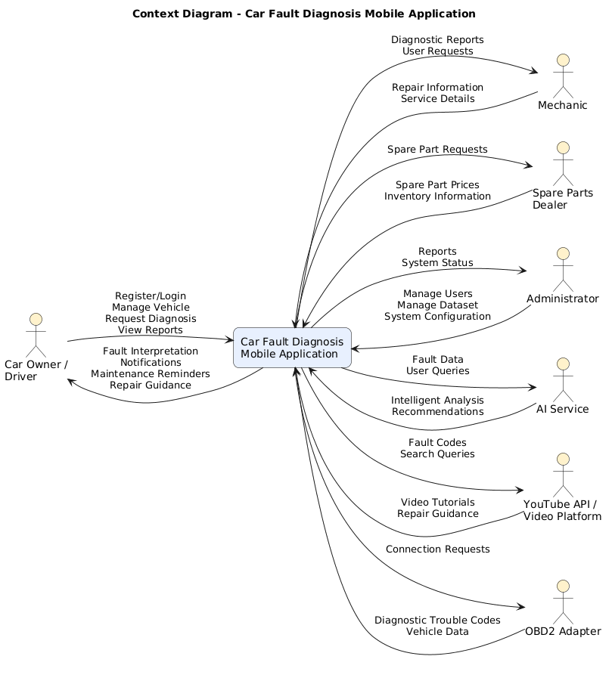
Figure 0.1
It shows the information exchanged between users and the application while defining the scope of the system. The Context Diagram provides a simplified view of the proposed solution and serves as the foundation for developing the Data Flow Diagrams presented in the following subsection.

3.3.3. Data Flow Diagram
A Data Flow Diagram (DFD) is a graphical representation of how data moves through a system. It illustrates the processes performed by the system, the data stores used to retain information, the external entities involved, and the flow of data between these components. Unlike the Context Diagram, which provides a high-level overview, Data Flow Diagrams reveal the internal processes that transform input data into useful outputs.
The Data Flow Diagram for the Car Fault Diagnosis Mobile Application (CAFAD) was developed at different levels of abstraction to provide a clear understanding of the system's internal operations. The Level 0 DFD presents the major functional processes of the application, while the Level 1 DFD further decomposes these processes into more detailed activities involved in vehicle fault diagnosis and system management.
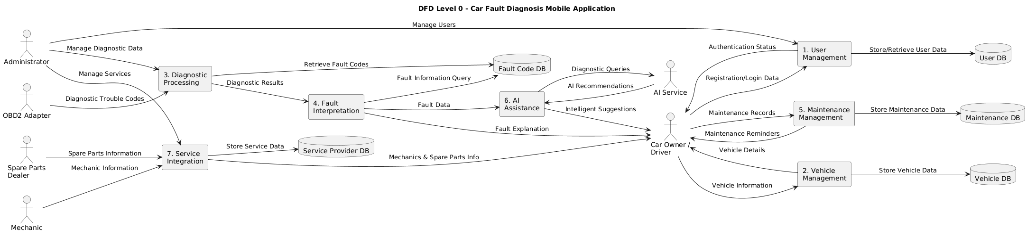
Figure 0.2
The Level 0 Data Flow Diagram presents the major processes of the system, including user authentication, vehicle management, intelligent fault diagnosis, diagnosis history management, AI-assisted chat, and service provider management. It also illustrates the interaction between these processes and the underlying PostgreSQL database, which stores user accounts, vehicle information, diagnosis records, and other operational data.
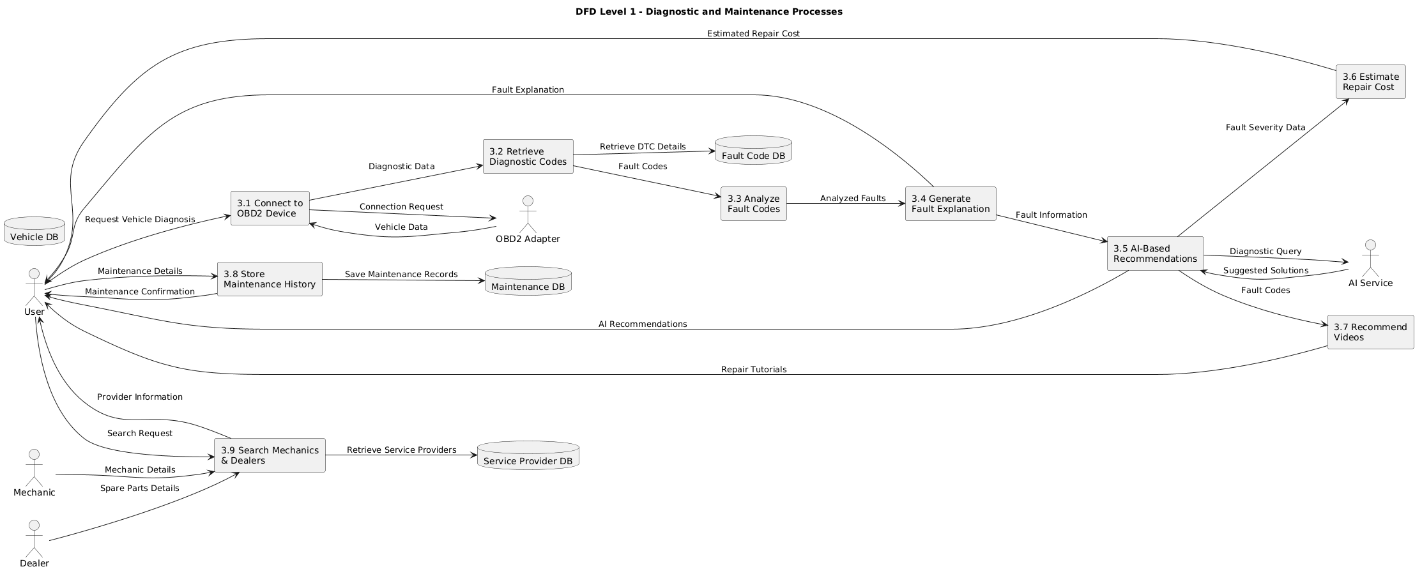
Figure 0.3
The Level 1 Data Flow Diagram provides a more detailed representation of the internal workflow of the vehicle fault diagnosis process. It shows how user-submitted symptoms are validated, analysed by the intelligent diagnosis module, matched with the knowledge base, and converted into diagnosis results together with maintenance recommendations. The generated diagnosis is then stored in the database and presented to the user for future reference.
The Data Flow Diagrams provide a comprehensive representation of the movement of information throughout the proposed system. They demonstrate how data is processed, stored, and exchanged among the various system components, thereby serving as an important design tool for understanding the internal behaviour of the application.

3.3.4. Use Case Diagram
A Use Case Diagram is a Unified Modeling Language (UML) diagram that illustrates the functional requirements of a system by showing the interactions between users (actors) and the services provided by the application. It provides a high-level view of the system's functionality and identifies the responsibilities of each user category without describing the internal implementation details.
The Use Case Diagram for the Car Fault Diagnosis Mobile Application (CAFAD) identifies the four primary actors of the system: Vehicle Owner, Mechanic, Automobile Parts Seller, and Administrator. Each actor interacts with the application according to the permissions assigned to their role.
The Vehicle Owner is the primary user of the application and is responsible for registering an account, logging into the system, managing vehicle information, performing symptom-based fault diagnosis, viewing diagnosis history, interacting with the AI assistant, locating registered mechanics and automobile parts sellers, updating profile information, and logging out of the application.
The Mechanic registers an account, authenticates into the system, manages their professional profile, updates their service information, views customer-related requests where applicable, and logs out after completing their activities.
The Automobile Parts Seller registers an account, logs into the application, manages business information, updates available services or products, maintains profile information, and logs out securely.
The Administrator supervises the overall operation of the application by managing user accounts, maintaining diagnostic knowledge, monitoring system activities, and ensuring the integrity and security of the application's data.
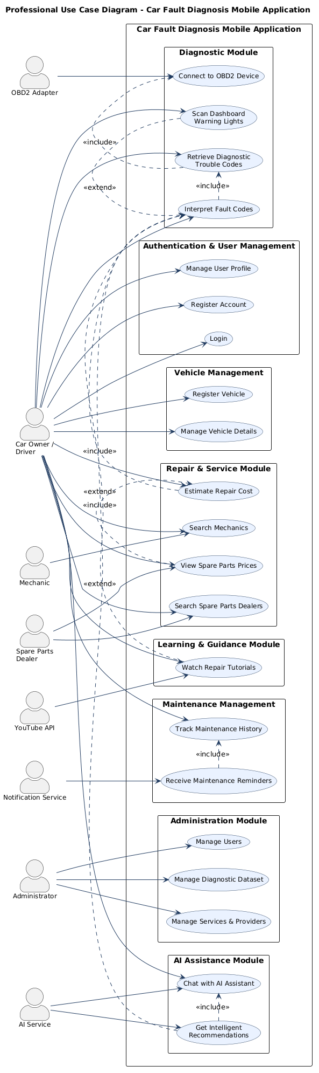
Figure 0.4
The Use Case Diagram shows that the Vehicle Owner performs most of the application's core functions, including vehicle registration, intelligent fault diagnosis, AI-assisted consultation, and viewing diagnosis history. Mechanics and Automobile Parts Sellers primarily manage their professional information so that vehicle owners can access their services when required. The Administrator performs system management activities that ensure the application operates efficiently and securely. The interactions presented in the diagram demonstrate how the different user categories collaborate within the system to achieve the overall objective of improving vehicle fault diagnosis and maintenance support.

3.3.5. Activity Diagram
An Activity Diagram is a behavioral diagram in the Unified Modeling Language (UML) used to represent the workflow of a system or business process. It illustrates the sequence of activities, decision points, and interactions that occur while executing a particular function. Activity diagrams help developers and stakeholders understand the logical flow of operations and identify how different tasks are performed within the system.
In the Car Fault Diagnosis Mobile Application (CAFAD), the Activity Diagram models the workflow of the vehicle fault diagnosis process. It describes the sequence of actions performed by the user and the system, beginning with user authentication, followed by symptom submission, intelligent fault analysis, and the presentation of diagnosis results. The diagram also illustrates the decision-making process involved in validating user inputs and generating appropriate diagnostic recommendations.
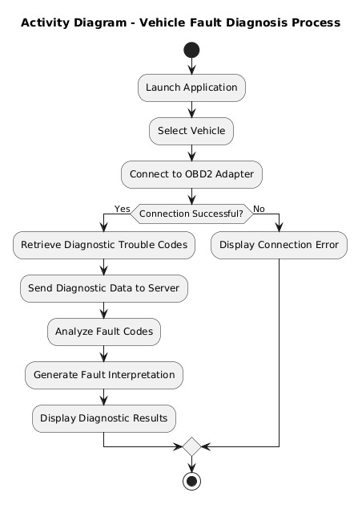
Figure 0.5
Figure 3.3 illustrates the workflow of the vehicle fault diagnosis process in CAFAD. The process begins when a registered user logs into the application and selects the fault diagnosis module. The user enters the observable symptoms of the vehicle, after which the system validates the information provided. If the submitted data is incomplete or invalid, the user is prompted to correct the input before proceeding.
Once the symptoms have been successfully validated, the intelligent diagnosis module analyses the information to determine the most probable vehicle fault. The application then retrieves the corresponding diagnosis and recommended corrective actions from the knowledge base. The diagnosis results are displayed to the user and simultaneously stored in the diagnosis history for future reference. The activity concludes when the user reviews the diagnosis and exits or continues using other features of the application.
The Activity Diagram demonstrates the logical sequence of operations performed by the system and highlights the interaction between the user and the intelligent diagnosis module. It also serves as a guide during implementation by ensuring that each stage of the diagnosis process is executed in the correct order.

3.3.6. Sequence Diagram
A Sequence Diagram is a behavioral diagram in the Unified Modeling Language (UML) that illustrates how different objects or system components interact over time to accomplish a particular task. It emphasizes the chronological order of message exchanges between actors and system components, making it useful for modelling dynamic system behaviour. Sequence diagrams help developers understand how system operations are executed and how different modules collaborate to fulfil user requests.
In the Car Fault Diagnosis Mobile Application (CAFAD), sequence diagrams were developed to model the interactions between users, the mobile application, the backend services, the intelligent diagnosis module, and the PostgreSQL database during the execution of key system functionalities. These diagrams provide a detailed representation of the communication that occurs while processing user requests and demonstrate the sequence in which different system components cooperate to complete specific operations.
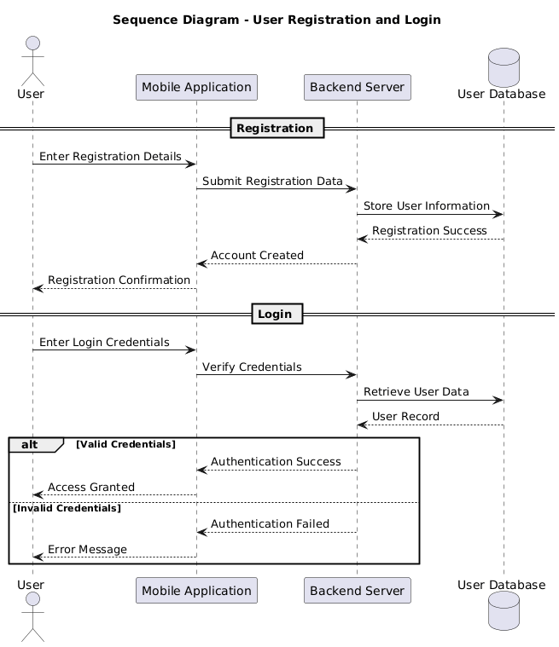
Figure 0.6
The User Authentication Sequence Diagram illustrates the interaction that occurs when a registered user logs into the application. The process begins with the user submitting login credentials through the mobile application. The application forwards the credentials to the authentication service, which verifies them against the information stored in the PostgreSQL database. If the credentials are valid, the system authenticates the user, determines the user's role, and grants access to the appropriate dashboard. Otherwise, an error message is returned to the user requesting valid credentials.
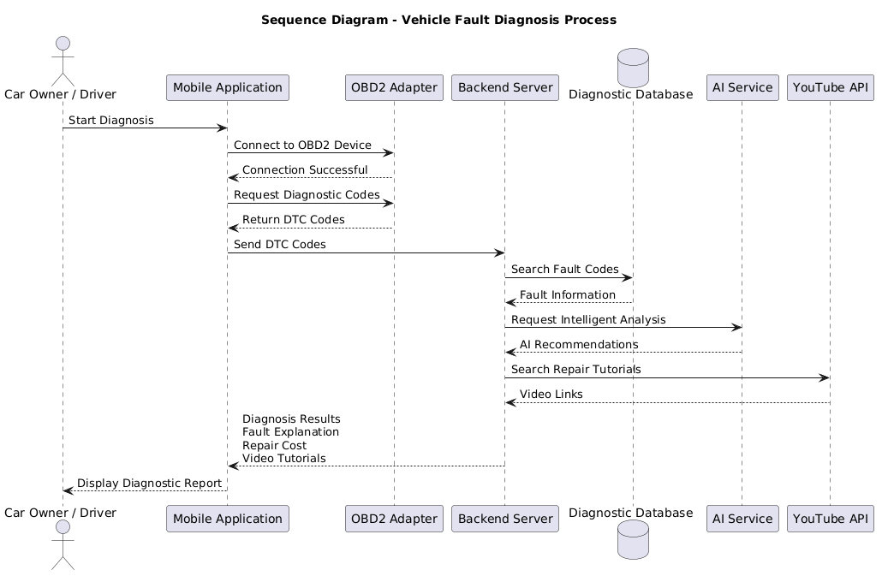
Figure 0.7
The Vehicle Fault Diagnosis Sequence Diagram illustrates the communication involved in diagnosing a vehicle fault. After selecting the diagnosis module, the user enters the observed vehicle symptoms. The application validates the submitted information and forwards it to the intelligent diagnosis module. The diagnosis engine analyses the symptoms, retrieves the most probable fault and the corresponding maintenance recommendations, stores the diagnosis record in the database, and finally returns the results to the user for review.
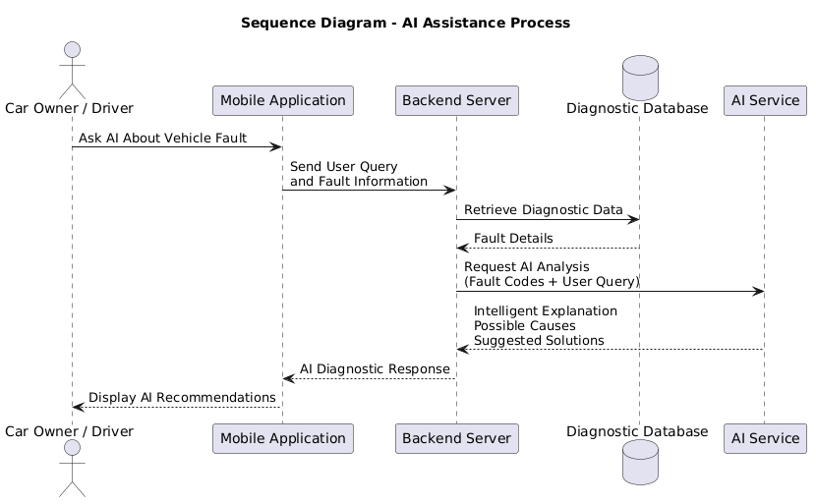
Figure 0.8
The AI Chat Sequence Diagram describes the interaction between the user and the AI-assisted chat module. The user submits a vehicle-related question through the chat interface, after which the application forwards the request to the AI service for processing. The AI analyses the request, generates an appropriate response, and sends the answer back to the application, where it is displayed to the user. This interaction enables users to obtain vehicle maintenance guidance and general automotive information through a conversational interface.
The sequence diagrams collectively illustrate the dynamic behaviour of the proposed system by showing how information flows among different software components during execution. They also validate the interaction between the user interface, backend services, intelligent diagnosis module, AI assistant, and PostgreSQL database, thereby providing a detailed understanding of the operational behavior of the Car Fault Diagnosis Mobile Application.

3.3.7. Class Diagram
A Class Diagram is a static structural diagram in the Unified Modeling Language (UML) that represents the classes within a system, together with their attributes, methods, and the relationships that exist among them. It provides a blueprint for the object-oriented design of a software application by illustrating how different classes collaborate to implement the required system functionalities. Class diagrams are particularly useful during software development because they guide implementation and promote modular, maintainable, and reusable code.
In the Car Fault Diagnosis Mobile Application (CAFAD), the Class Diagram models the main software entities and the relationships among them. It defines the core classes required to support user management, vehicle management, fault diagnosis, diagnosis history, AI-assisted chat, mechanics management, and automobile parts seller management. The diagram also illustrates how these classes interact to achieve the overall functionality of the application.
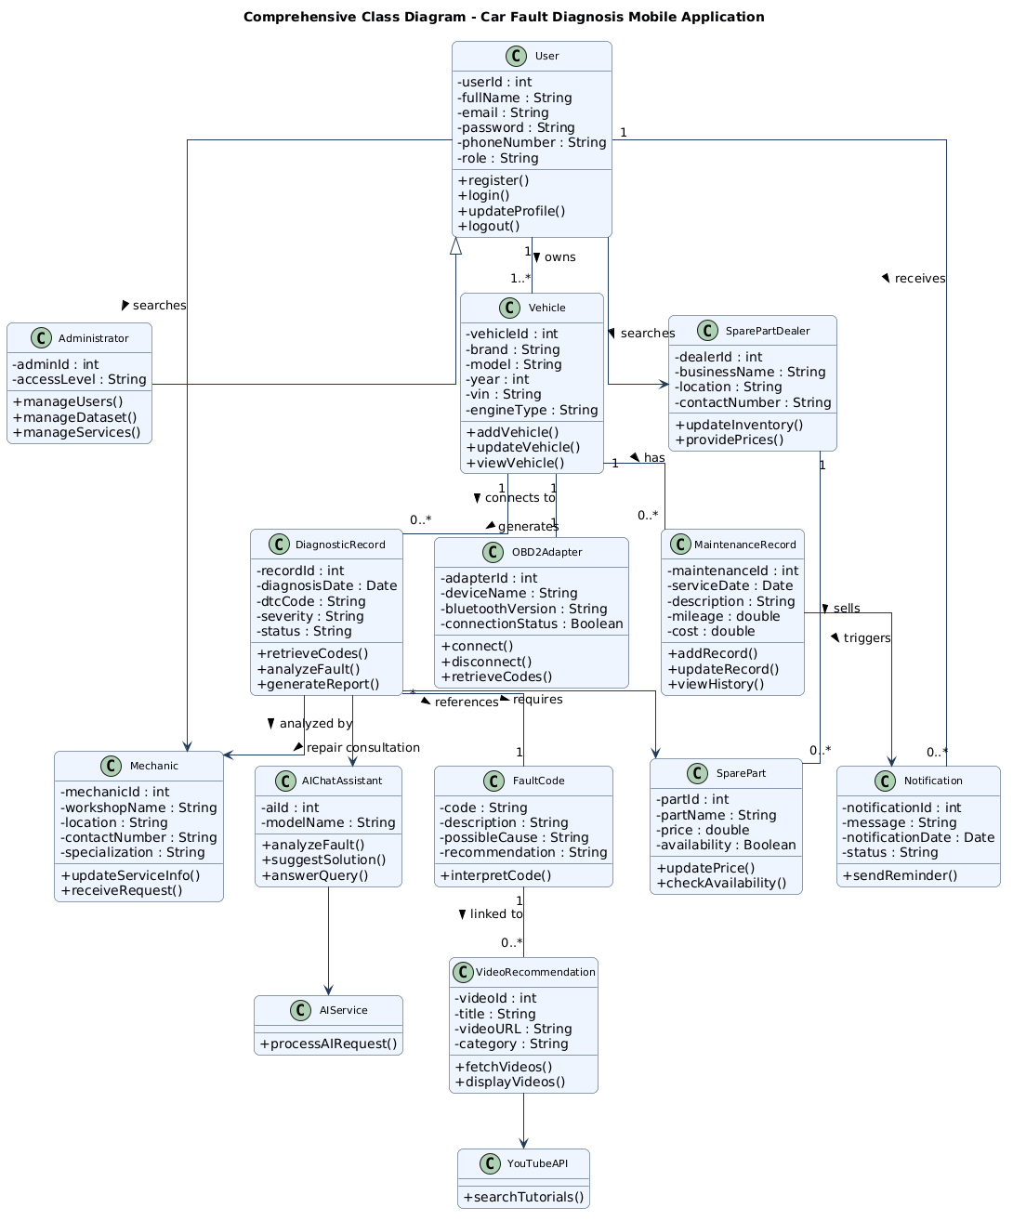
Figure 0.9
Figure 3.7 presents the Class Diagram of the proposed system. The User class serves as the central entity and contains common user information such as personal details, authentication credentials, and account information. Specialized users, including vehicle owners, mechanics, automobile parts sellers, and administrators, interact with the system according to their assigned roles and privileges.
The Vehicle class stores information about registered vehicles, including vehicle identification details and ownership information. A vehicle owner may register one or more vehicles, establishing a one-to-many relationship between the User and Vehicle classes.
The Diagnosis class is responsible for storing vehicle symptoms, diagnostic results, recommended corrective actions, and the date on which the diagnosis was performed. Each diagnosis record is associated with a specific vehicle, allowing users to maintain a complete diagnosis history for future reference.
The Mechanic and Parts Seller classes manage information related to registered service providers. These classes contain professional and business details that enable vehicle owners to identify and contact mechanics or automobile parts sellers when maintenance services or replacement parts are required.
The AI Chat class supports conversational interaction between users and the intelligent assistant by managing user queries and generated responses. This class enhances user experience by providing maintenance advice, answering vehicle-related questions, and assisting users throughout the diagnosis process.
The relationships illustrated in the Class Diagram demonstrate how the various system components collaborate to provide a comprehensive vehicle fault diagnosis platform. The diagram also served as the foundation for implementing the application's object-oriented architecture and ensuring consistency between the software design and the database structure.

3.3.8. Deployment Diagram
A Deployment Diagram is a structural UML diagram that illustrates the physical deployment of software components onto hardware devices and the communication links between them. It provides a runtime view of the system by showing where application components are installed and how they interact across the deployment environment. Deployment diagrams are useful for understanding the system's infrastructure and the distribution of software services.
For the Car Fault Diagnosis Mobile Application (CAFAD), the Deployment Diagram illustrates the physical architecture of the application, including the user's Android mobile device, the application server, the PostgreSQL database server, and the AI service. It also shows the communication paths between these components through the internet, demonstrating how user requests are processed and how data is exchanged within the system.
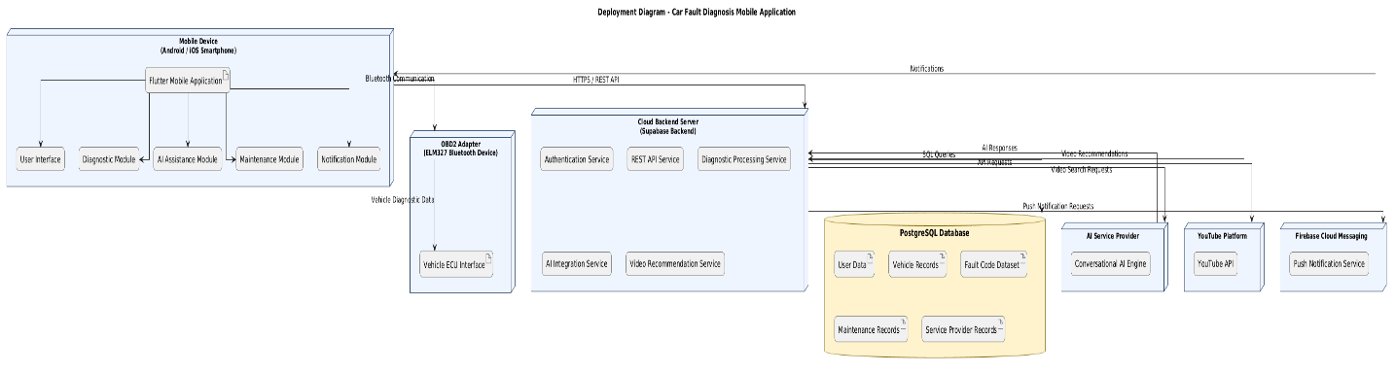
Figure 0.10
The Deployment Diagram shows that users access the application through an Android mobile device running the Flutter-based client application. User requests are transmitted over the internet to the backend server, where authentication, business logic, and fault diagnosis processes are executed. The backend communicates with the PostgreSQL database server to store and retrieve application data, including user accounts, vehicle records, diagnosis history, and service provider information. When users interact with the AI assistant, the backend exchanges requests and responses with the AI service before returning the generated results to the mobile application.
This deployment architecture provides a clear separation between the presentation layer, application layer, and data layer, thereby improving system scalability, maintainability, and security. It also enables the application to support multiple users simultaneously while ensuring efficient communication between all system components.

3.4. Partial Conclusion
This chapter presented the analysis and design of the Car Fault Diagnosis Mobile Application (CAFAD). It began by describing the proposed development methodology and the functional and non-functional requirements that guided the development of the system. These requirements provided a clear understanding of the expected behavior and quality attributes of the application.
The chapter also presented the design models used to represent the structure and behavior of the proposed system. The Context Diagram and Data Flow Diagrams illustrated the flow of information between the system and its external entities, while the UML diagrams, including the Use Case Diagram, Activity Diagram, Sequence Diagrams, Class Diagram, and Entity Relationship Diagram (ERD), described the functional interactions, system workflow, object relationships, and database structure. The global architecture of the solution and the resolution process further demonstrated how the various components of the system work together to provide intelligent vehicle fault diagnosis and maintenance support.
The analysis and design models developed in this chapter served as the blueprint for implementing the application. They ensured that the proposed system satisfies the identified user requirements while providing a scalable, secure, and maintainable software architecture.
The next chapter presents the implementation of the Car Fault Diagnosis Mobile Application (CAFAD), including the development environment, implementation of the various system modules, testing procedures, and the results obtained from evaluating the completed application.

Chapter 4: IMPLEMENTATION AND RESULTS

4.1. Introduction
Following the analysis and design presented in the previous chapter, this chapter focuses on the implementation and evaluation of the proposed Car Fault Diagnosis Mobile Application (CAFAD). The implementation phase involved translating the designed system architecture, database model, user interfaces, and application logic into a fully functional mobile application using the selected software technologies.
The chapter first presents the development tools, programming languages, frameworks, and other materials used during the implementation of the system. It then describes the implementation process, highlighting the major development activities carried out to build the application's core functionalities, including user authentication, vehicle management, fault diagnosis, AI-assisted chat, diagnosis history, and directories of registered mechanics and automobile parts sellers.
The chapter also presents the results obtained from implementing the system through screenshots and descriptions of the application's various interfaces. These results demonstrate how the developed application satisfies the functional requirements identified during the analysis phase. Finally, the solution is evaluated to determine how effectively it addresses the identified problem, before concluding the chapter with a brief summary of the implementation outcomes.

4.2. Tools and Materials Used
The successful implementation of the Car Fault Diagnosis Mobile Application (CAFAD) required the use of various hardware and software resources. These tools facilitated the design, development, testing, debugging, and deployment of the application. The selected technologies were chosen based on their compatibility, performance, ease of development, and ability to support cross-platform mobile application development. The following subsections describe the hardware and software tools used during the implementation process.

4.2.1. Hardware Requirements
The development and testing of CAFAD were carried out using personal computers with specifications sufficient to support mobile application development, database management, and emulator execution.

Component | Specification
Computer Type | Laptop
Processor | Intel Core i5 (or equivalent)
RAM | 8 GB
Storage | 512 GB SSD
Operating System | Windows 11 (64-bit)
Internet Connection | Required for package installation, Supabase services, and AI communication
Mobile Device | Android smartphone for application testing
Table 2
The above hardware configuration provided adequate processing power and memory for developing the Flutter application, running the Android emulator when required, managing the PostgreSQL database through Supabase, and testing the application's functionalities on both an emulator and a physical Android device.

4.2.2. Software Requirements
Several software tools were employed throughout the implementation of CAFAD. Each tool played a specific role in the development lifecycle, ranging from coding and interface design to version control and database management.
Software | Purpose
Flutter SDK | Cross-platform mobile application development
Dart Programming Language | Application logic and interface development
Visual Studio Code | Source code editing and debugging
Android Studio | Android SDK, emulator, and device management
Git | Version control
GitHub | Remote repository and project backup
Supabase | Backend-as-a-Service providing PostgreSQL database, authentication, and storage
PostgreSQL | Relational database management system
Postman | API testing and validation
Google Chrome | Testing Flutter web builds and Supabase dashboard access
Table 3
These software tools collectively provided a complete development environment that supported efficient coding, testing, debugging, data management, and version control throughout the implementation of the project.

4.2.3. Development Technologies
The implementation of CAFAD relied on several modern technologies that work together to provide a scalable, secure, and user-friendly mobile application.
- Flutter Framework: Flutter was used as the primary development framework because it enables the creation of high-performance cross-platform mobile applications from a single codebase. Its rich widget library made it possible to design responsive and visually consistent user interfaces for all system users.
- Dart Programming Language: Dart served as the programming language for implementing the application's business logic, state management, navigation, and interaction with backend services. Its seamless integration with Flutter contributed to improved application performance.
- Supabase: Supabase was used as the backend platform for the application. It provided user authentication, secure data storage, PostgreSQL database services, and API endpoints for communication between the mobile application and the database.
- PostgreSQL: PostgreSQL served as the relational database management system responsible for storing user accounts, vehicle information, diagnosis records, mechanic profiles, automobile parts seller information, and other application data. Its reliability and support for relational data structures made it suitable for the project's requirements.
- Riverpod State Management: Riverpod was adopted to manage application state efficiently. It simplified data flow across different screens, improved code organization, and enhanced maintainability by separating business logic from the user interface.
- GoRouter: GoRouter was used to manage navigation within the application. It provided a structured routing mechanism that enabled smooth movement between authentication screens, dashboards, diagnostic pages, and other application modules.
The combination of these technologies resulted in a robust and maintainable application architecture capable of supporting the functional and non-functional requirements identified during the analysis and design phases.

4.3. Description of the Implementation Process
The implementation of the Car Fault Diagnosis Mobile Application (CAFAD) followed the system design presented in Chapter Three. The application was developed incrementally using the Flutter framework and integrated with a PostgreSQL database hosted on Supabase. Each functional module was implemented independently before being integrated into the complete system. This modular development approach simplified testing, debugging, and maintenance while ensuring that each component satisfied its intended functionality.
The implementation process consisted of several stages, including project initialization, database implementation, user authentication, development of the core functional modules, and system integration. The following subsections describe these stages.

4.3.1. Project Initialization
The implementation began with the creation of a new Flutter project and the configuration of the required development environment. The Flutter SDK, Dart programming language, Android SDK, and other dependencies were installed and configured to support cross-platform mobile application development. The project directory was then organized into logical modules to improve code readability and maintainability.
Several Flutter packages were incorporated into the project to facilitate state management, navigation, database communication, image selection, and user authentication. The project also adopted a layered architecture that separates the presentation layer, business logic, and data access components, thereby promoting modularity and ease of maintenance.

4.3.2. Database Implementation
The backend database was implemented using PostgreSQL through the Supabase platform. Based on the Entity Relationship Diagram developed in Chapter Three, the database tables were created to store information relating to users, vehicles, diagnoses, mechanics, automobile parts sellers, AI conversations, and other system data.
Relationships between tables were established using primary and foreign keys to maintain data integrity and eliminate redundancy. Appropriate constraints and validation rules were also applied to ensure consistency during data insertion and updates.
The completed database was then connected to the Flutter application using Supabase's client libraries, allowing secure communication between the mobile application and the backend database.
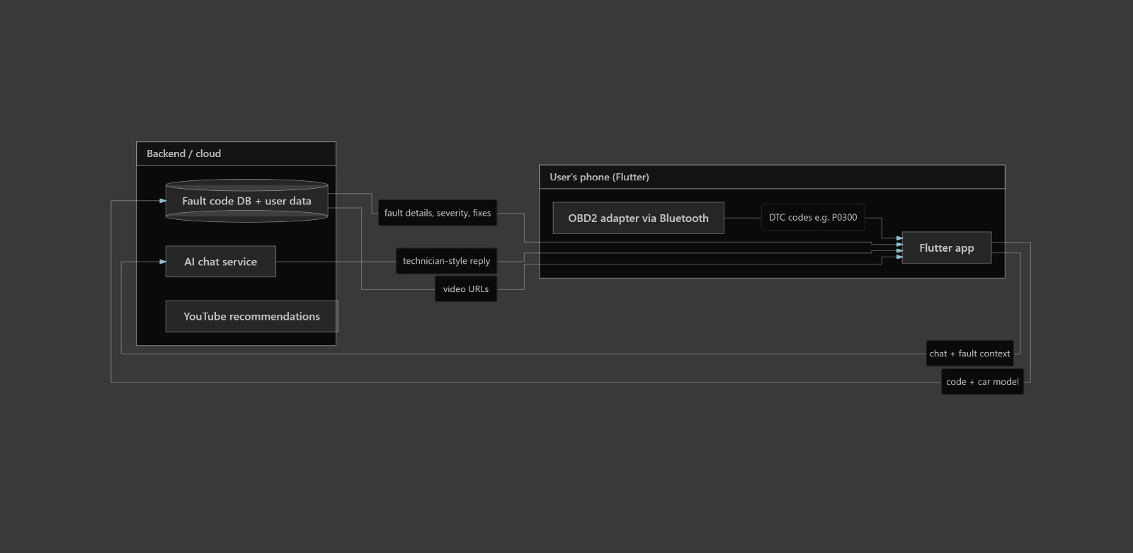
Figure 0.1
The successful integration of the database enabled real-time storage and retrieval of application data throughout the system.

4.3.3. User Authentication Module
The authentication module was implemented to regulate access to the application's services based on user roles. The module supports account registration, user login, password recovery, and secure session management.
During registration, users provide the necessary personal information and select their respective roles, namely Vehicle Owner, Mechanic, or Automobile Parts Seller. User credentials are validated before being stored securely in the PostgreSQL database through Supabase Authentication.
Once authenticated, users are redirected to dashboards corresponding to their assigned roles, ensuring that only authorized users can access the functionalities available to them. This role-based access mechanism enhances system security and improves user experience.

4.3.4. Vehicle Management Module
The vehicle management module allows vehicle owners to maintain records of their vehicles within the application. Users can register new vehicles by providing information such as the vehicle brand, model, manufacturing year, registration number, fuel type, and engine specifications.
The module also supports updating and deleting vehicle information whenever necessary. By maintaining accurate vehicle records, the application is able to provide more relevant diagnostic results during fault analysis.
Vehicle information is stored in the PostgreSQL database and is linked directly to the corresponding vehicle owner's account.
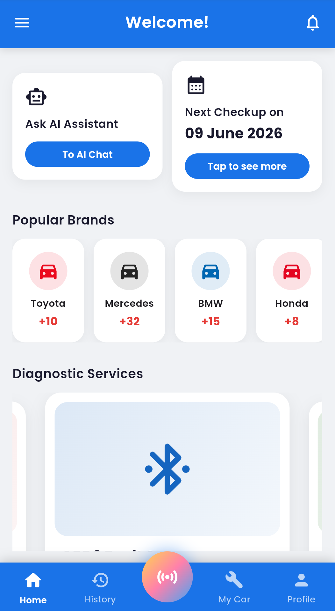
Figure 0.2

4.3.5. Fault Diagnosis Module
The fault diagnosis module constitutes the core functionality of CAFAD. This module enables vehicle owners to identify possible vehicle faults by selecting or entering the symptoms observed in their vehicles.
After receiving the symptom information, the application processes the input using the predefined diagnostic knowledge incorporated into the system. The diagnosis engine analyses the submitted symptoms and generates one or more probable faults together with appropriate recommendations for corrective actions.
Each diagnosis is stored in the user's diagnosis history, allowing previous diagnostic sessions to be reviewed whenever required.

4.3.6. AI-Assisted Chat Module
To further assist users during the diagnostic process, CAFAD incorporates an AI-powered chat module that enables users to ask vehicle-related questions in natural language.
The chat interface communicates with an external artificial intelligence service through secure API requests. Responses received from the AI service provide additional explanations, maintenance recommendations, and troubleshooting guidance beyond the predefined diagnosis results.
The conversation history is maintained to improve user interaction and provide continuity during consultations.
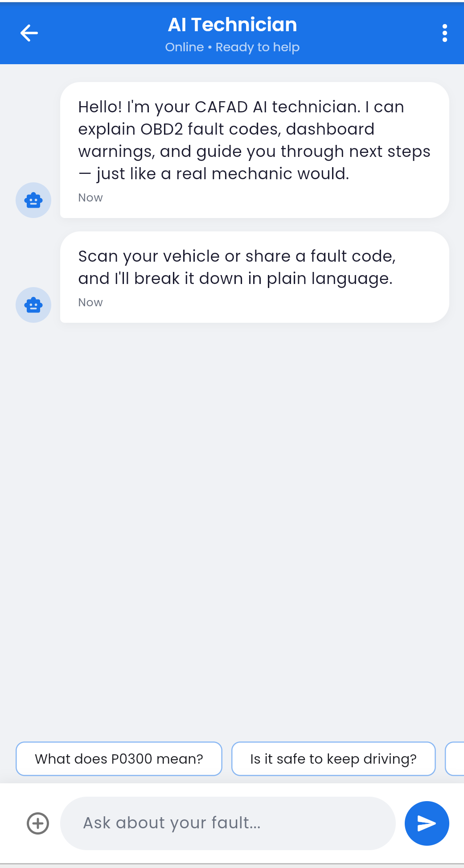
Figure 0.3

4.3.7. Directory of Mechanics and Automobile Parts Sellers
CAFAD includes directories that enable users to locate registered mechanics and automobile parts sellers within the application.
Mechanics and automobile parts sellers create professional profiles containing relevant business information, contact details, location, and descriptions of the services or products they offer. Vehicle owners can browse these directories after obtaining a diagnosis to identify professionals capable of resolving the identified fault or supplying the required replacement parts.
The directory information is retrieved dynamically from the PostgreSQL database whenever requested.

4.3.8. Administrator Module
The administrator module provides centralized control over the entire application. Through this module, the administrator manages user accounts, verifies registered professionals, monitors system activities, and maintains the integrity of application data.
Administrative operations include approving or removing mechanic and automobile parts seller accounts, monitoring diagnosis records, and performing general system maintenance. Access to these functionalities is restricted exclusively to users with administrative privileges.

4.3.9. System Integration and Testing
After implementing the individual modules, they were integrated to form the complete CAFAD application. Integration testing was carried out to verify that communication between the frontend, backend, and database operated correctly.
Several test scenarios were executed to validate user authentication, vehicle registration, diagnosis generation, AI-assisted chat, profile management, and data retrieval. Errors identified during testing were corrected through iterative debugging until the application satisfied the functional requirements specified during the analysis phase.
The completed application demonstrated stable performance and successfully integrated all major system components into a unified mobile platform.

4.4. Presentation and Interpretation of Results
This section presents the results obtained after implementing the Car Fault Diagnosis Mobile Application (CAFAD). The implemented system was tested to verify that all the functional requirements identified during the analysis phase were successfully achieved. The application's user interfaces are presented through screenshots, accompanied by descriptions and interpretations of their functionalities.
The screenshots illustrate the major modules of the application, including user authentication, vehicle management, fault diagnosis, AI-assisted chat, diagnosis history, and the directories of registered mechanics and automobile parts sellers. Together, these results demonstrate that the developed application provides a practical and user-friendly platform for assisting vehicle owners in diagnosing common vehicle faults and locating relevant automotive service providers.

4.4.1. Splash Screen
The splash screen is displayed immediately after the application is launched. It presents the CAFAD logo while the application initializes essential resources such as user session information and backend connections. This screen provides users with visual feedback that the application is loading successfully. The successful display of the splash screen confirms that the application initializes correctly before navigating users to the appropriate interface.

4.4.2. Login Screen
The login interface enables registered users to access the application securely by entering their email address and password. The interface also provides links for account registration and password recovery. Successful authentication grants users access to dashboards corresponding to their assigned roles, thereby ensuring secure and role-based access to system functionalities.

4.4.3. User Registration Screen
The registration interface allows new users to create accounts by providing their personal information and selecting their respective roles within the system. Upon successful registration, user information is securely stored in the PostgreSQL database through Supabase Authentication, allowing the newly created account to be used immediately.

4.4.4. Dashboard
Following successful authentication, users are redirected to their dashboards. The dashboard serves as the central navigation point from which users can access the application's major functionalities.
Although the available options vary according to user roles, the dashboard maintains a consistent interface that enhances usability and ease of navigation.

Figure 0.4
The dashboard provides quick access to diagnosis services, vehicle management, AI chat, diagnosis history, and user profile management.

4.4.5. Vehicle Management
The vehicle management interface enables vehicle owners to register, update, and manage their vehicles. Maintaining accurate vehicle information improves the relevance of diagnostic recommendations generated by the system.
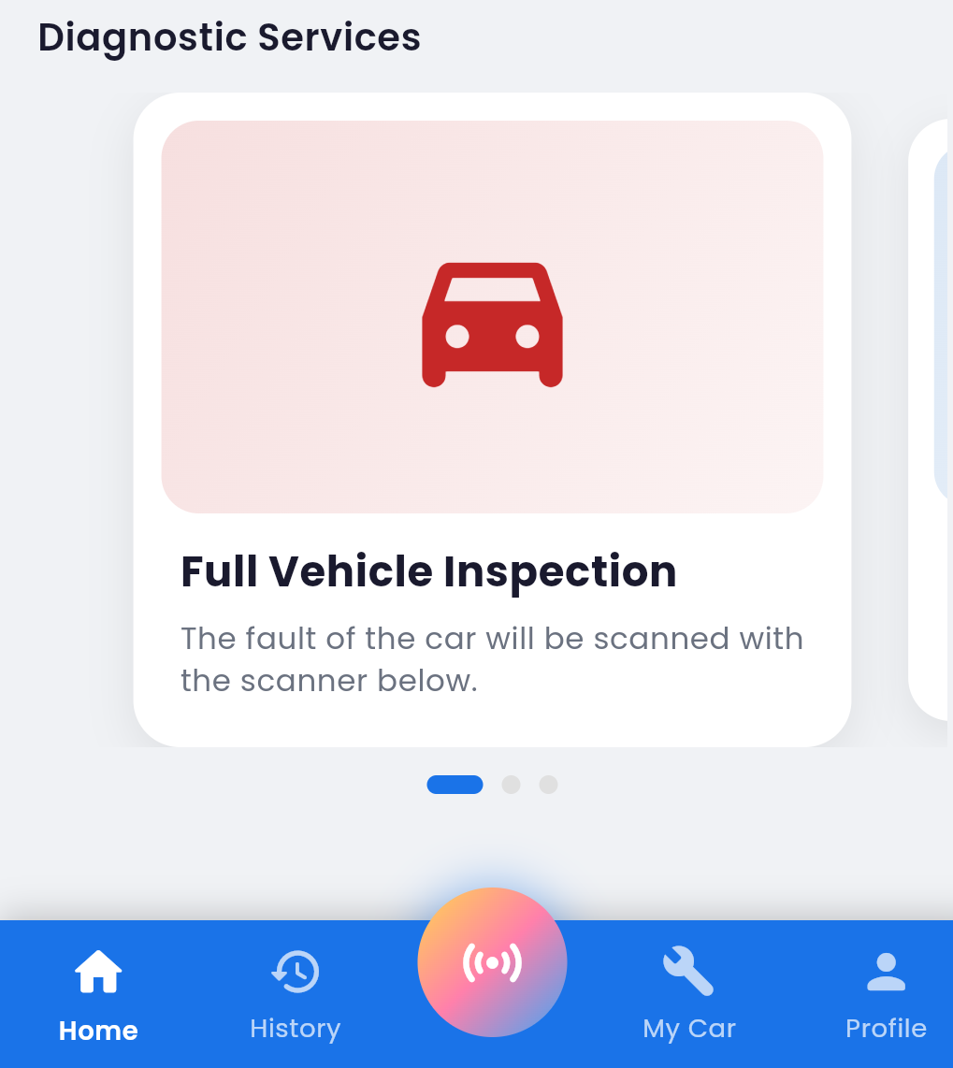
Figure 0.5
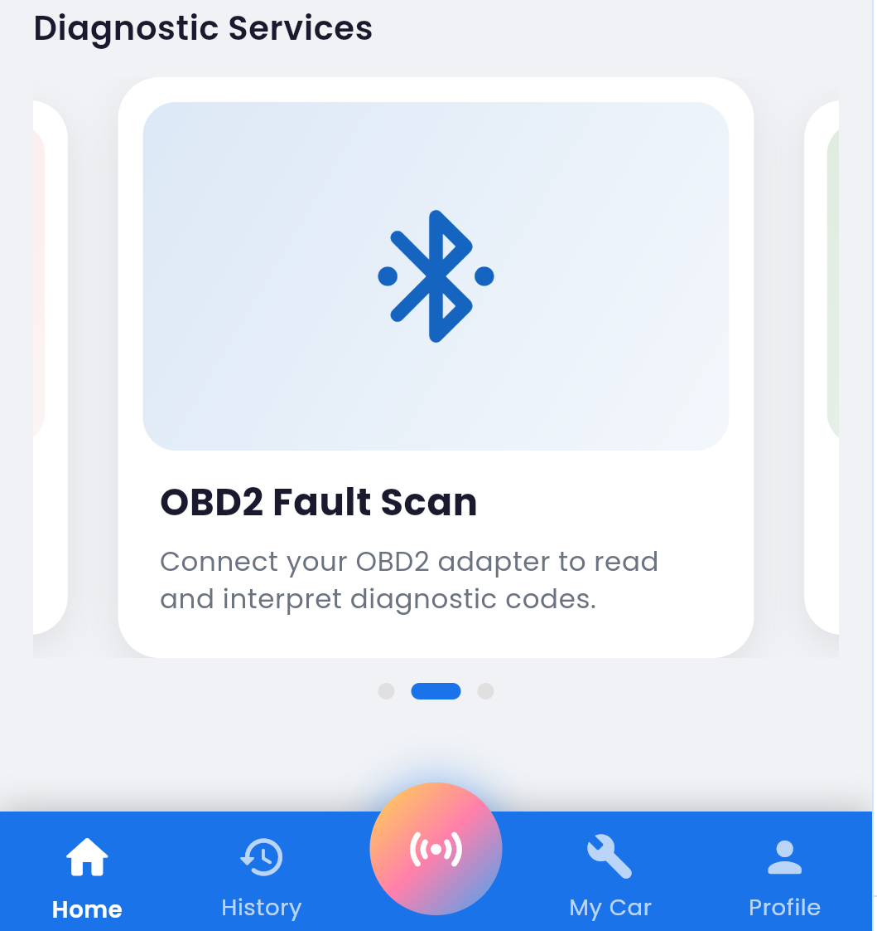
Figure 0.6
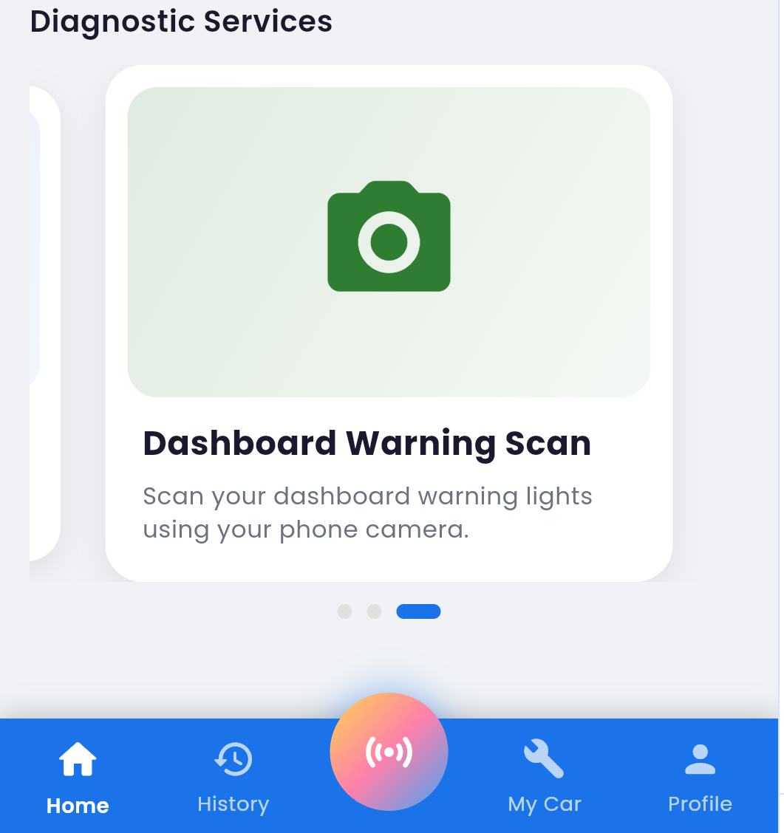
Figure 0.7
The successful implementation of this module ensures that each diagnosis can be associated with the correct vehicle.

4.4.6. Fault Diagnosis Interface
The diagnosis interface allows users to enter or select observed vehicle symptoms before initiating the diagnosis process. After the user submits the selected symptoms, the system analyses the input and identifies the most probable faults.

4.4.7. Diagnosis Results
After processing the submitted symptoms, the application displays the diagnosis results, including the suspected fault(s) and recommended corrective actions. The results provide users with immediate guidance regarding possible causes of the observed symptoms and appropriate maintenance recommendations.

4.4.8. AI-Assisted Chat
The AI chat interface enables users to interact with an intelligent virtual assistant capable of answering vehicle-related questions beyond the predefined diagnosis process.

Figure 0.8
This functionality enhances the application's usefulness by providing personalized explanations and maintenance advice in natural language.

4.4.9. Diagnosis History
The diagnosis history module stores all previous diagnosis sessions performed by a user. This allows users to review past diagnoses without repeating the diagnostic process.
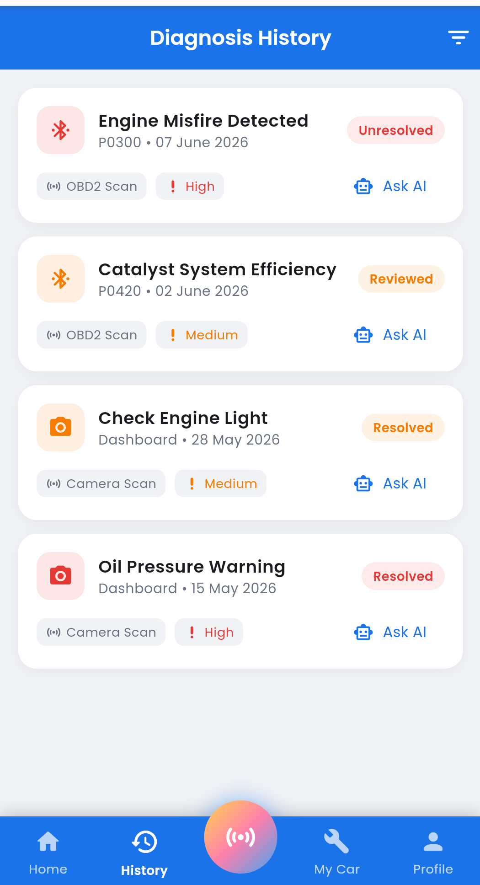
Figure 0.9
The availability of diagnosis history supports better vehicle maintenance by enabling users to monitor recurring faults over time.

4.4.10. Mechanics Directory
The mechanics directory displays profiles of registered mechanics available within the system. Users can browse mechanic profiles and obtain contact information after receiving a diagnosis.
This feature bridges the gap between fault identification and professional repair services.

4.4.11. Automobile Parts Sellers Directory
The automobile parts sellers directory provides users with access to registered vendors offering vehicle spare parts.
This functionality enables users to locate replacement parts required to address diagnosed faults, making CAFAD a more comprehensive automotive support platform.

4.4.12. User Profile Management
The profile management interface allows users to update their personal information, modify account settings, and maintain accurate profile details.
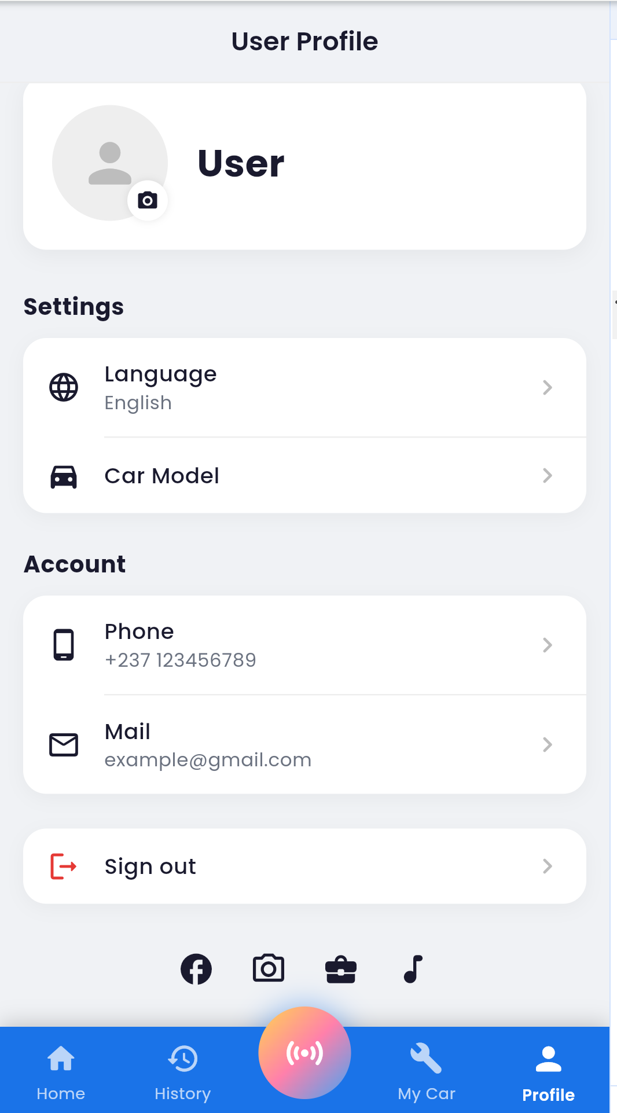
Figure 0.10
This module contributes to maintaining accurate user records and improving the overall user experience.
The administrator dashboard provides authorized personnel with tools for managing users, monitoring system activities, and maintaining application integrity.
The successful implementation of the administrator module demonstrates that the system supports centralized management of user accounts and application resources.

4.5. Evaluation of the Solution
The evaluation of the Car Fault Diagnosis Mobile Application (CAFAD) was conducted to assess whether the developed system satisfies the objectives and requirements established during the analysis and design phases. The evaluation focused on the system's functionality, usability, performance, security, and overall effectiveness in assisting users with vehicle fault diagnosis.
The application was tested under different usage scenarios involving the various categories of users, namely Vehicle Owners, Mechanics, Automobile Parts Sellers, and the Administrator. The results indicate that the implemented solution successfully achieves the primary goal of providing an intelligent and user-friendly platform for diagnosing common vehicle faults while facilitating access to automotive service providers.

4.5.1. Functional Evaluation
The functional evaluation examined whether the implemented features operate according to the specified functional requirements.
The evaluation confirmed that users can successfully create accounts, authenticate securely, manage their vehicles, perform vehicle fault diagnosis, consult the AI-assisted chat, access diagnosis history, and browse directories of registered mechanics and automobile parts sellers. Likewise, administrative functions such as user management and system monitoring operate as intended.
Overall, the implemented functionalities correspond closely to the system requirements identified in Chapter Three, demonstrating that the application successfully fulfills its intended purpose.
Functional Requirement | Expected Outcome | Observed Outcome | Status
User Registration | Users create accounts successfully | Successfully implemented | Pass
User Authentication | Secure login and logout | Successfully implemented | Pass
Vehicle Management | Users manage vehicle records | Successfully implemented | Pass
Fault Diagnosis | System generates diagnosis from symptoms | Successfully implemented | Pass
AI-Assisted Chat | Users receive AI-generated assistance | Successfully implemented | Pass
Diagnosis History | Previous diagnoses are stored and retrieved | Successfully implemented | Pass
Mechanics Directory | Users browse registered mechanics | Successfully implemented | Pass
Parts Sellers Directory | Users browse registered parts sellers | Successfully implemented | Pass
Table 4

4.5.2. Performance Evaluation
The performance evaluation focused on the responsiveness and stability of the application during normal operation.
Testing showed that the application launches successfully, authenticates users within a short period, retrieves database records efficiently, and generates diagnosis results without noticeable delays under normal network conditions. Communication between the Flutter frontend and the Supabase backend remained stable throughout the testing process.
The use of Flutter's optimized rendering engine and PostgreSQL's efficient data management contributed significantly to the application's overall performance. Although certain features, such as the AI-assisted chat, depend on internet connectivity and external API response times, the application maintained satisfactory responsiveness during testing.

4.5.3. Usability Evaluation
The usability evaluation assessed how easily users could interact with the application and complete their intended tasks.
The application provides a clean and intuitive interface with consistent navigation across all modules. Clearly labeled menus, well-organized screens, and straightforward workflows enable users with varying levels of technical knowledge to use the application effectively.
Role-based dashboards further improve usability by presenting users with only the functionalities relevant to their responsibilities. This reduces interface complexity and enhances the overall user experience.
The integration of AI-assisted guidance and diagnosis history also contributes to improved usability by providing users with additional support during the diagnostic process.

4.5.4. Security Evaluation
Security was considered throughout the implementation of CAFAD to ensure the protection of user information and system resources.
The application uses Supabase Authentication to verify user identities and manage secure login sessions. Role-based access control restricts access to sensitive functionalities according to the user's assigned role. User credentials are securely managed by the authentication service, while database access is governed through predefined authorization policies.
These security mechanisms help prevent unauthorized access to sensitive information and contribute to the overall reliability of the application.

4.5.5. Evaluation Against the Project Objectives
The effectiveness of CAFAD was further evaluated by comparing the implemented solution with the objectives defined in Chapter One.
Project Objective | Evaluation
Develop a mobile application for vehicle fault diagnosis | Achieved
Provide intelligent diagnosis based on observed symptoms | Achieved
Enable management of vehicle information | Achieved
Integrate AI-assisted consultation | Achieved
Provide access to registered mechanics | Achieved
Provide access to automobile parts sellers | Achieved
Maintain diagnosis history | Achieved
Implement secure user authentication | Achieved
Table 5

4.5.6. Limitations of the Solution
Despite the successful implementation of CAFAD, certain limitations remain.
The accuracy of the diagnosis depends on the quality and completeness of the symptoms provided by the user. Incorrect or insufficient symptom descriptions may lead to less accurate diagnostic suggestions. Additionally, the AI-assisted chat and backend services require an active internet connection, limiting functionality in offline environments.
The current implementation focuses on common vehicle faults and does not interface directly with vehicle onboard diagnostic (OBD-II) systems. Consequently, diagnoses are based on user-reported symptoms rather than real-time sensor data. Furthermore, the directories of mechanics and automobile parts sellers rely on registered users within the system, meaning their usefulness increases as more professionals join the platform.
These limitations provide opportunities for future enhancements, including offline support, direct OBD-II integration, advanced machine learning models for diagnosis, and location-based recommendations.

4.6. Partial Conclusion
This chapter presented the implementation and evaluation of the Car Fault Diagnosis Mobile Application (CAFAD). It described the tools and technologies used, the implementation of the main system modules, and the results obtained through testing and screenshots of the application's key features.
The evaluation showed that CAFAD successfully meets the project's objectives by providing a reliable and user-friendly platform for vehicle fault diagnosis, vehicle management, AI-assisted support, and access to automotive service providers. Although there is room for future improvements, the developed application demonstrates that the proposed solution effectively addresses the problem identified in Chapter One. The next chapter concludes the report by summarizing the project, discussing its limitations, and suggesting directions for future work.

Chapter 5: CONCLUSION AND FURTHER WORKS

5.1. Summary of Findings
This project focused on the design and implementation of the Car Fault Diagnosis Mobile Application (CAFAD), a mobile solution developed to assist vehicle owners in identifying common vehicle faults based on observed symptoms. The study was motivated by the challenges many vehicles owners face in recognizing faults at an early stage and accessing reliable automotive support.
To address these challenges, a cross-platform mobile application was developed using Flutter, with Supabase and PostgreSQL serving as the backend infrastructure. The application provides secure user authentication, vehicle management, fault diagnosis, AI-assisted consultation, diagnosis history, and directories of registered mechanics and automobile parts sellers. Different user roles, including Vehicle Owners, Mechanics, Automobile Parts Sellers, and the Administrator, were implemented to ensure that each user has access to functionalities relevant to their responsibilities.
The implementation and evaluation results demonstrated that CAFAD successfully meets the objectives defined at the beginning of the project. The application performed reliably during testing, offering an intuitive user interface and integrating its various modules into a functional and cohesive system. Overall, the project confirms that mobile technologies combined with intelligent diagnostic support can improve access to vehicle maintenance information and facilitate connections between vehicle owners and automotive service providers.

5.2. Contribution to Engineering and Technology
The development of the Car Fault Diagnosis Mobile Application (CAFAD) contributes to the field of software engineering by demonstrating how mobile technologies and modern backend services can be combined to solve real-world problems in the automotive sector. The project showcases the practical application of Flutter, PostgreSQL, and artificial intelligence in the development of a secure, scalable, and user-friendly mobile application.
From a technological perspective, CAFAD provides a digital platform that simplifies the process of identifying common vehicle faults based on user-reported symptoms. By integrating AI-assisted consultation, vehicle management, diagnosis history, and directories of registered mechanics and automobile parts sellers into a single application, the system offers a more convenient approach to vehicle maintenance support.
The project also serves as a practical reference for future research and development in intelligent automotive applications. It demonstrates how mobile computing, database systems, and AI technologies can be integrated to improve access to diagnostic information and automotive services, particularly in environments where immediate professional assistance may not always be available.

5.3. Recommendations
Based on the outcomes, we recommend the following:
- The diagnostic knowledge base should be continuously updated to include a wider range of vehicle faults, symptoms, and maintenance recommendations in order to improve the accuracy and reliability of the diagnosis provided by the application.
- Future developers should consider integrating the application with On-Board Diagnostics (OBD-II) devices to enable real-time vehicle data acquisition and more precise fault diagnosis.
- Advanced artificial intelligence and machine learning techniques should be explored to enhance the system's ability to generate more accurate and personalized diagnostic recommendations based on historical data and user interactions.
- Additional features such as offline diagnostic capabilities, location-based recommendations for nearby mechanics and automobile parts sellers, and multilingual support should be incorporated to improve the accessibility and usability of the application.
- Further research should be conducted to evaluate the application's performance using a larger and more diverse group of users and vehicle types. Such studies would provide valuable insights for improving the system and validating its effectiveness in real-world automotive environments.

5.4. Difficulties Encountered
During the development of this project, several challenges were encountered. These difficulties were addressed through continuous testing, debugging, consultation of technical documentation, and iterative improvements throughout the development process.
One of the main challenges was integrating the Flutter frontend with the Supabase backend while ensuring reliable communication with the PostgreSQL database. Proper configuration of authentication, database queries, and access control policies required careful implementation and testing to ensure secure and consistent data management.
Another challenge involved designing a fault diagnosis process capable of providing meaningful recommendations based on user-reported symptoms. Since the application relies on symptom-based diagnosis rather than direct vehicle sensor data, developing an effective diagnostic logic required careful organization of the knowledge base to produce relevant and useful results.
The integration of the AI-assisted chat feature also presented challenges, particularly in managing API communication and ensuring that responses were delivered efficiently while maintaining a smooth user experience. In addition, testing the application across different devices and screen sizes required adjustments to the user interface to ensure consistent performance and responsiveness.
Despite these challenges, the problems encountered were successfully resolved, leading to the development of a functional, reliable, and user-friendly mobile application that met the objectives of the project.

5.5. Further Works
Although CAFAD successfully meets the objectives of this project, there is still room for improvement. Future work could focus on integrating On-Board Diagnostics (OBD-II) technology to enable real-time vehicle diagnostics and improve the accuracy of fault detection. The application could also incorporate more advanced AI and machine learning techniques to provide smarter and more personalized diagnostic recommendations.
In addition, future versions may include features such as offline diagnosis, location-based recommendations for nearby mechanics and automobile parts sellers, and appointment booking services. Further testing involving a wider range of vehicle models and users is also recommended to enhance the system's performance, reliability, and overall effectiveness.

APPENDIX

REFERENCES
Beck, K., Beedle, M., van Bennekum, A., Cockburn, A., Cunningham, W., Fowler, M., Grenning, J., Highsmith, J., Hunt, A., Jeffries, R., Kern, J., Marick, B., Martin, R. C., Mellor, S., Schwaber, K., Sutherland, J., & Thomas, D. (2001). Manifesto for Agile Software Development. Retrieved from https://agilemanifesto.org
Fling, B. (2009). Mobile Design and Development. O'Reilly Media.
Gamma, E., Helm, R., Johnson, R., & Vlissides, J. (1994). Design Patterns: Elements of Reusable Object-Oriented Software. Addison-Wesley.
Google. (2025). Dart Programming Language Documentation. Retrieved from https://dart.dev
Google. (2025). Flutter Documentation. Retrieved from https://docs.flutter.dev
Goodfellow, I., Bengio, Y., & Courville, A. (2016). Deep Learning. MIT Press.
Martin, R. C. (2018). Clean Architecture: A Craftsman's Guide to Software Structure and Design. Prentice Hall.
OWASP Foundation. (2024). OWASP Mobile Application Security Testing Guide. Retrieved from https://owasp.org
PostgreSQL Global Development Group. (2025). PostgreSQL Documentation. Retrieved from https://www.postgresql.org/docs/
Pressman, R. S., & Maxim, B. R. (2020). Software Engineering: A Practitioner's Approach (9th ed.). McGraw-Hill Education.
Riverpod Contributors. (2025). Riverpod Documentation. Retrieved from https://riverpod.dev
Russell, S., & Norvig, P. (2021). Artificial Intelligence: A Modern Approach (4th ed.). Pearson.
SAE International. (2021). On-Board Diagnostics (OBD-II) Standards Overview. SAE International.
Sommerville, I. (2016). Software Engineering (10th ed.). Pearson.
Supabase. (2025). Supabase Documentation. Retrieved from https://supabase.com/docs
The Flutter Community. (2025). GoRouter Package Documentation. Retrieved from https://pub.dev/packages/go_router

